USU FIELD SAFETY HANDBOOK

Draft

Picture 1:

Picture url: https://qcnr.usu.edu/

1/31/23
This handbook provides guidelines and resources to conduct safe, successful field courses and research trips. The content focuses on hazards and risks relevant for Utah State University – based courses, research, international trips, research expeditions, and other outdoor excursions. Field sites may include field stations, natural reserves, public lands, parks, wilderness areas, coastline, or waterways. This handbook may be used for more controlled sites such as urban/suburban areas, rural, construction areas, excavations, mines, etc. The Field Safety Handbook was developed to serve as a reference document and teaching tool to aid in the development of a comprehensive field safety plan. This field safety plan is to be the framework for safety, accountability, and emergency response for those you are responsible, as well as your trip. The manual is organized into key sections on planning, incident response, and incident reporting, as well as appendices on common field hazards and local campus resources.
Faculty, staff, and students, including student employees and volunteers, are accountable for health and safety rules and following safe work practices, including:
3 most important takeaways:
Effective Hazard Analysis and Risk Assessment Skills
Ability to develop a comprehensive Field Safety Plan
Communications skills
- Obtaining appropriate training for designated activities
- Creating, developing, and implementing safety plans
- Using personal protective equipment (PPE) and safety equipment as required and directed
- Reporting unsafe conditions, malfunctioning equipment, and other safety concerns
- Maintaining communication during field activities
- Reporting all injuries and incidents
- Understanding what to do in the event of an emergency
Assumption of Risk
All classes, programs, and extracurricular activities within the University involve some risk, and certain ones involve travel. The University provides opportunities to participate in these programs on a voluntary basis. Therefore, students should not participate in them if they do not assume the risks. Students can ask the respective program leaders/sponsors about the possible risks a program may generate, and if students are not willing to assume the risks, they should not select that program. By voluntarily participating in classes, programs, and extracurricular activities, a student does so at his or her own risk. General information about University Risk Management policies, insurance coverage, vehicles use policies, and risk management forms can be found at: http://www.usu.edu/riskmgt/.
Codes of Conduct
This manual is intended for use in conjunction with official USU class or research activities. Participants are reminded that these activities are part of the university, and this the USU Code of Conduct applies. Please see https://studentconduct.usu.edu/studentcode/article1 and related materials.
USU is committed to the safety of all students, faculty, and staff. Please follow all University, State, and Local guidance in order to remain safe and minimize the possibility of contracting or spreading communicable diseases while conducting researching/working. For more information please visit the following links regarding disease safety in Utah:
https://rules.utah.gov/publicat/code/r386/r386-702.htm
https://www.usu.edu/covid-19/
https://www.cdc.gov/quarantine/final-rules-control-communicable-diseases.html

Parts of this handbook are taken from the University of California’s Field Operations Safety Manual

Preface

Risk, and recognizing the possibility of loss or injury, is important to experiential learning and is inherent in field environments where we teach and conduct research. A field instructor or researcher should act as an effective risk manager who understands and anticipates, insofar as they can, the risks and acts appropriately to reduce the likelihood of negative consequences. Accidents often result from a combination of challenging conditions, inadequate preparation, and poor communication. For this reason, an effective trip leader must incorporate many attributes of leadership including preparation, competency, effective communication, appropriate judgement, self and group awareness, and tolerance for adversity and uncertainty.

This document is written in accordance with USU Policy 5?? Field Research Safety Policy and can be found at (insert URL here) and will be updated as needed to remain current with best field practices.

Table of Contents
Contents
Chapter 1: Planning 12
Written Field Safety Plan 12
Travel Authorization 12
Forms 12
Trip Registration 13
Risk Assessment 13
Definitions 13
Risk Assessment 13
Evaluating the “Accident Potential” 14
Developing Conservative Judgement 14
Identify appropriate equipment, gear, and first aid supplies 15
First Aid Kits 15
Medical Training Requirements: 17
Medical Training Recommendations: 18
Communications 18
Communications Frequency 19
Communications Equipment 19
Important safety equipment to bring to the field 20
Outdoor Essentials 20
Safety equipment to bring in your vehicle 21
Paperwork and forms/documentation 21
Transportation options and precautions 21
Potential Field Hazards 23
Chapter 2: “What to do when things go wrong” 26
Incident Response and Reporting 26
First Aid & Initial Response 26
Life-Threatening Injuries or Illness 26
Basic First Aid 26
Seeking Medical Care or Other Support 27
During Travel 27
Incident Reporting 27
Lessons Learned 27
Chapter 3: Resources for Trip Leaders 28
Best Practices for Trip Leaders 28
Facilitating Safe Group Decision-Making 28
Effective Communication 28
Set the tone for a safe learning environment 28
Establish and maintain reasonable goals, roles, expectations/behavioral norms 29
Brief your team often 31
Practice active listening 32
Paraphrasing 32
Drawing People Out 32
Resolving Conflict 32
Addressing student/participant behavior in the field 33
Appendix A: Training 35
Training 35
Leadership Skills 35
Basic Outdoor Skills 35
Leave No Trace & Outdoor Ethics 35
Specialized “Task Based” Skills 36
Climbing or Working at Heights 36
Operating Power Tools or Equipment 36
Excavating or Trenching 36
Entering Confined Spaces such as Caves, Vaults, or Mines 37
Handling Wildlife 37
Clinical Work or Handling Biological Specimens 37
Transporting Hazardous Materials, Hazardous Waste, or Biological Specimens 37
Use of Drones 38
Safety Resources for Specific Areas of Study 38
Agriculture/Earth Sciences: 38
Polar Sciences – US Antarctica Program, Arctic Sciences (NSF): 38
Wildlife Biology: 38
Archaeology, Paleontology, Anthropology, Others: 38
Working Alone Off-Site (CCOHS Fact Sheet): 38
Guidelines for Social Worker Safety: 38
Safety of Journalists: 39
USU Field Safety Plan 40
SAMPLE SAFETY & EMERGENCY PLAN (revised 18 March 2022) 47

Introduction

This Utah State Field Safety Handbook is meant to help you develop a field safety plan that answers 5 questions:
Who?
When?
Where?
What are you doing?
What is important to know about your trip?
As a researcher at Utah State you have the opportunity to conduct cutting edge, world shaping research all over the globe. With this extraordinary opportunity also comes a great deal of responsibility.



University Policy 5??: Field Research Safety Policy

Category: TBD
Sub Category: (if applicable) TBD
Covered Individuals: University Employees, Students, and Volunteers
Responsible Executive: Vice President of Research
Policy Custodian: Vice President of Research
Last Revised: N/A
Previous USU Policy Number: N/A

5??.1 Purpose and Scope

Utah State University (USU) is committed to providing opportunities for faculty, staff and students to collect data outside the semi-controlled workplaces found in USU campuses, laboratories, or libraries as part of a course or formal research study. This policy is meant to establish the minimum safety requirements for conducting field research including anything from data collection in a populated area to a remote location in Alaska.

There is no research or educational objective that justifies taking avoidable risks with the health and safety of yourself or others. All individuals performing field research or course work on behalf of USU are responsible for ensuring they work in a safe and conscientious manner and follow this policy at all times. Failure to follow these policies and procedures may make you individually liable in the case of accident or injury.

This policy is expected to be fully adopted by September 1st 2022. With the expectation that by the beginning of the 2023 field research season (i.e. May, 2023) all USU field research activities are in full compliance. All projects initiated after September 1st 2023, must have available funding to cover all costs associated with the requirements of the policy.

5??.2 Policy

2.1 General Requirements for Field Research Safety:

2.1.1 Travel all field research activities that require a travel authorization must adhere to USU Travel Policy 515. See Travel Policy 515 for travel authorization requirements.

2.1.2 Safety all field research activities or trips must file a Field Safety Plan (FSP) with their department or college that at a minimum addresses the requirements identified in the USU Field Safety Handbook.

2.1.3 Communications Plan all field safety plans must include a communications plan that establishes; the means of communication, and the frequency of communication as determined by the guidelines set forth in the USU Field Safety Handbook.

- Field research activities conducted in a wilderness location or any other location that does not have continuous reliable cell phone service must have an alternate means of communication readily available (i.e. satellite phone, spot tracker, inReach or other approved method). See USU Field Safety Handbook for details on suggested equipment.

2.1.4 First Aid Kits all field research activities must have access to a first aid kit. See the USU Field Safety Handbook for which type of first aid kit is required for your type of research or location.

2.2 Training

2.2.1 Medical training required medical training depends upon location and remoteness of field research site or activity type. See the USU Field Safety Handbook for details.

2.2.2 Other training site specific safety training or project specific safety training may also be required. As set forth by the project supervisor, department, college, or other USU policies. (e.g. OHV Training course required by USU Policy 539)

5??.3 Responsibilities

3.1 College or Department Responsibilities

Establish and implement a College or Department Field Research Safety Program that shall, at a minimum, include:
- Conditions under which working alone is prohibited.
- An internal review and endorsement procedure that demonstrates it (the College or Department) is satisfied that the supervisor’s Field Safety Plan is appropriate and that the action plan items have been, are being, or will be implemented.
- An accountability procedure that verifies its employees’ departure from (check-out), and return to (check-in), their day-to-day place of work (e.g. USU Main Campus, Ag Research Station, etc.).

3.2 Supervisor Responsibilities

- Follow all procedures, guidelines, provisions, and/or responsibilities described in your College or Department’s Field Research Safety Program.
- Follow currently recognized best safety practices for the location, environment and type of research.
- Manage the development and implementation of your research group’s project specific Field Safety Plan prior to conducting any field research. See USU Field Safety Handbook for requirements.
- Provide and document employee training:
  - Including University, College, or Department, required safety training(s).
  - Safety training identified as risk-appropriate in the Field Safety Plan.
- Annually update Field Safety Plan(s).

3.3 Faculty, Staff, Student Employee, Students, Graduate Student or Volunteer Responsibilities

- Conduct all field research in accordance with your operational unit’s Field Safety Plan and College or Department’s Field Research Program.
- In a timely manner, inform your supervisor of any changes to existing or newly discovered risks that might undermine the hazard control measures described in the Field Safety Plan.
- Take adequate precautions to protect your own safety at all times.

5??.4 References

- USU Field Safety Handbook (hyperlink)

5??.5 Related USU Policies

- Policy 515 Travel
- Policy 539 Off Highway Vehicle (OHV) Usage

Information below is not included as part of the contents of the official Policy. It is provided only as a convenience for readers/users and may be changed at any time by persons authorized by the President, subject to review by the USU Policy Committee.

Resources

- None.

Policy History

Original issue date: TBD

Last review date: N/A

Next scheduled review date: N/A

Previous revision dates: N/A

Chapter 1: Planning

This chapter is laid out in the logical order of planning a trip and developing a field safety plan. The USU Field Safety Policy on the previous pages lays out the requirements for compliance with the policy, as well as the responsibilities of each level of leadership in the university structure.
The field safety plan is not just a requirement that should be checked off without putting thought into it. It is a chance for you as a leader to ensure the safety of yourself and those that you bring on your trip with you and peace of mind in case of an emergency.

Written Field Safety Plan
Taking the time to compile a thorough safety plan and discussing it with your team will prepare you to more effectively manage risks inherent to field work. Written field safety plans should include site information and emergency procedures. It will serve as a risk assessment tool and can include Go/No Go criteria. The plan should refer to other protocols or training and be used to brief your field team or course participants on trip logistics and precautions. Developing and using a field safety plan is required for any activities that include conducting field research or teaching field courses off campus, or work performed at field stations, nature reserves, and controlled sites (USU Field Safety Policy 5??)). Established site procedures may be available for the field site you will be visiting, but a safety plan specific for the hazards to your research or objectives is still required.

Travel Authorization
Ensure that when planning a trip, USU Policy 515: Travel is taken into account and is complied with.

Forms
- A Fillable Field Safety Plan template can be found in Appendix C: Example Trip Planning Forms
- USU Travel Authorization (TA) through Service Now
  - Training on how to submit a TA request: https://usu.app.box.com/s/ym56vg15p4cc1u26td7qt9qagmpcgiel
  - https://usu.service-now.com/usu/travel_new_ta.do
Travel Reimbursement Request: https://usu.service-now.com/usu/travel_new_tr.do

Trip Registration
Field activities and the associated Field Safety Plan should be filed with the college or department. This will allow the department and university to be prepared and better able to provide beneficial assistance in the unlikely event of an unforeseen emergency. Filing the Field Safety Plan with the department will also allow for a peer review by colleagues that may have experience or knowledge working in similar environments or with the expected hazards.

Risk Assessment
One of the first things that needs to be done in order to write the Field Safety Plan is to conduct a thorough risk assessment and hazard identification. This next section defines terms and how to identify hazards

Definitions
Risk assessment is the process in which you as the leader of a trip get the opportunity to brainstorm what could possibly happen that could harm my students/volunteers/researchers/colleagues/etc. and how can I make sure that I am preventing that to keep my people as safe as possible.
A hazard is the potential for harm (physical or mental), often associated with a condition or activity that, if left uncontrolled, can result in an injury or illness.
A risk is the chance or probability that a person can experience harm or adverse health effects if exposed to a hazard.
Examples of Risks:
      - Smoking
      - Driving without a seatbelt
      - Conducting work without the proper PPE
An unsafe condition is when the environment around you is not conducive to your personal safety, and an unsafe act is when you disregard the hazards present in that environment and continue working without mitigating those hazards.
Example of an Unsafe Condition and Act:
- Having a cement saw with no guard over the blade while cutting rock at an archaeological dig site and then using it anyway knowing that it has a much greater potential to hurt you.

Risk Assessment
- Involve your workers
- Review accident history
- Conduct a hazard analysis
- If any hazards occur work together to remedy them.
- If any hazards exist that pose an immediate danger to life or health, take immediate action to protect workers. (OSHA) (https://www.osha.gov/sites/default/files/publications/osha3071.pdf)
- List and rank jobs according to hazards that are most likely to occur and most severe consequences to begin analyzing them first.
- Create an SOP that instructs workers the proper, safe way to complete the task
- One job may have multiple SOPs

Evaluating the “Accident Potential”
Always ask yourself: If we get into an accident right here, could I justify my actions and decision-making when I describe this back home? Two forces overlap when most accidents occur:
- Objective factors: These are environmental hazards presented by the natural world, such as weather, darkness, falling rocks, moving water, lightning, snow, exposure, avalanche, cold, hot, or deep water, etc.
- Subjective factors: These are human characteristics that often play a role when accidents occur. They include complacency, overconfidence, distraction, differing perception of risk, expectations and peer pressure, fatigue, stress, haste, and lack of competence.
Use the Equation: Risk = Likelihood x Consequences of an Accident Occurring

This graphic depicts the Go/No Go concept integrated into our field safety plans. Some conditions may be clear “No Go” situations, e.g. lightning, high waves, extreme heat, washed out roads, etc., but many challenging field situations will fall into the “amber” boxes.

Developing Conservative Judgement
Judgement is the logical reasoning we use to help us decide what to do in a new situation. It’s based on our past experience and personal reflection that leads to an insight or changed behavior that you carry forward with you. A few important points to remember about developing conservative judgement:
- Experience alone does not develop conservative judgement! Plenty of people take the same extreme risks over and over again. Reflection from one’s experience that leads to a modified future action is just as important as experience.
- We are going to make mistakes – the key is to learn from them.
- There are better and worse times to make mistakes – you don’t want to push your limits when you’re leading a group. Do this on your own time.
- It’s good for beginners to have simple, clear, “unbreakable” rules, such as: never climb a peak after noon in the mountains (because of the lightning strike potential). Over time your judgement will help you develop more nuanced rules.
- Often you must follow policies set forth by your organization that may conflict with what your judgement tells you to do. Follow your protocols.
- Sometimes you don’t have the experience to use good judgement – it is ok to stop and not do something.
- Supervisors don’t typically get upset if you’re “too safe”, but people will get upset (and potentially hurt!) if you get in over your head.

Identify appropriate equipment, gear, and first aid supplies
No one plans to be injured or to become ill, and we all sincerely hope that all field activities transpire without any illnesses or accidents. But, it is an unfortunate fact that accidents do occur and must be addressed. The better we are prepared to respond to unforeseen accidents the better the outcome and the higher the likelihood that everyone will return safe and whole. The Field Safety Plan will address three areas regarding to accidents, injuries and illnesses: First Aid Kits, First Aid Training, and Reliable communication strategies to request advanced emergency medical services. In addition to first aid and medical services, fieldwork often requires additional safety supplies. Some work at sites may lack basic services such as electricity, plumbed water, shelter from the elements, or designated pathways. During the planning stages, it is important to identify and budget for all equipment necessary to address both the foreseeable and the unexpected when working in the field.

First Aid Kits
Any excursion into the field should include a first aid kit (OSHA Field Safety and Health Manual) These are supplies necessary for treating persons that are injured or become ill. Because it is difficult to provide first aid care without these supplies, the old adage, “it is better to have and not need then to need and not have” is exceptionally pertinent. Because there is no perfect list for what should be included in a first aid kit. It is important that possible hazards are evaluated to predict possible injuries. Then ensure that your first aid kit fits your needs and is capable of treating probable injuries you may experience in the field. Considerations to take into account when deciding on a first aid kit are:
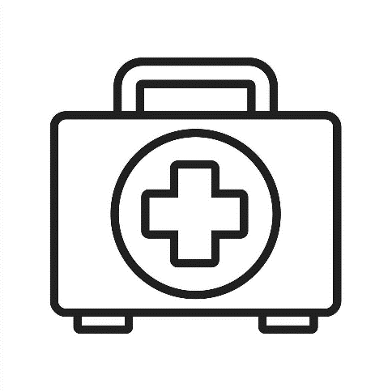
- First aid kits don’t save lives, people do. Get trained and know how to use everything in your first aid kit
- Commercial first aid kits are good starting points. North American Rescue, the NOLS Store, and other vendors such as REI and Adventure Medical Kits have options designed for outdoor excursions for various group sizes
- Pre-packaged kits may not contain all of the supplies you might need in your kit. Consider evaluating your hazards and buying and stocking more trauma supplies (tourniquets, chest seals/petroleum gauze, etc.) in order to treat severe life-threatening traumatic injuries.
- Customize your kit for your destination and group size
- Pack extra gloves
- Re-pack your first aid kit for each trip; replenish used or expired items
- Check for expiration dates on medications and sterile items; replace items that may have been torn open or damaged. Many vendors sell refill kits
- Leave an empty plastic bag in your kit for garbage. Be strict with all users of the kit to use the trash bag

The size and contents of a first aid kit are dependent upon what outdoor activity you are participating in and how far from emergency medical service you conduct field work. In general, there are two types of first aid kits; Class A and Class B. Class A first aid kits are able to treat small cuts and other minor injures common in the workplace. Class B kits are more substantial and are able to treat more severe injuries occurring in higher-risk environments. The first aid kit that you choose to bring on a trip must be capable of treating the injuries possible to be seen in the field. If working with heavy machinery, a first aid kit with trauma supplies (tourniquet, trauma dressings, etc.) would be indicated.
ANSI/ISEA Z308.1-2015 establishes minimum content requirements for both Class A and Class B first aid kits.
In addition to the first aid kit kept at the work site, it is recommended to have an additional Class B first aid kit (or even larger) staged in a vehicle or at camp
The EH&S Office has Class B first aid kits that you can borrow if your field activities are small, limited or sporadic. Please visit https://research.usu.edu/ehs/inreach-first-aid-kit-checkout to check out first aid kits and InReach devices.

Medical Training Requirements:
Field work is often done away from normal emergency services. Thus, group members may be the only ones available to render first aid. Because of this, at least one person at a minimum in a field group conducting field research or work must have first aid training. It is best practice to have multiple medically trained people on a trip in case the primary medically trained individual is not available or is the patient. It is also recommended by the American Red Cross that everyone have at least a minimal understanding of first aid.
First Aid/CPR/AED is highly recommended if you are conducting field research in an area where definitive medical care (i.e. a hospital) is less than one hour away. This one hour limit must include first responder response time and transport time.
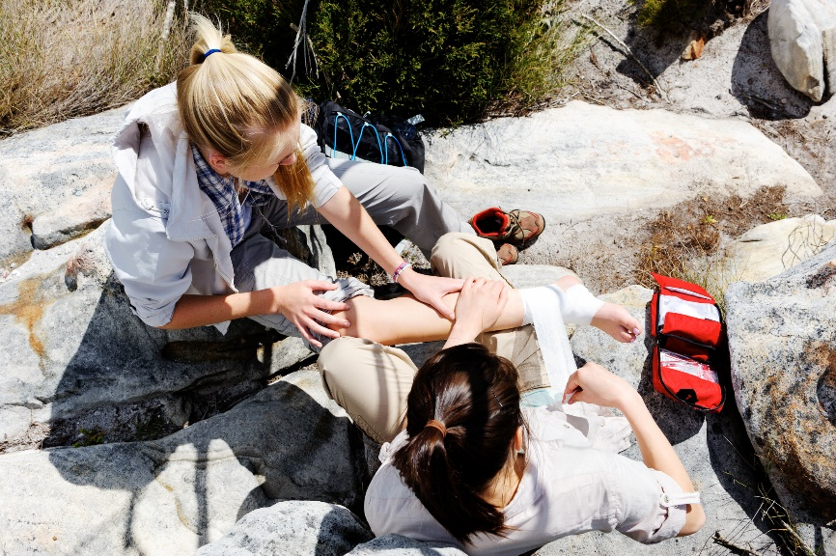
Wilderness First Aid is required if you are conducting field research in an area where definitive medical care is greater than one hour away. Wilderness First Aid is also required if you are conducting high risk activities such as: operating chainsaws or other dangerous machinery, operating an OHV, etc. outside of an urban setting regardless of the distance to the hospital.
This course is a great introduction to wilderness medicine and basic life support skills. It is perfect for the outdoor enthusiast who wants more than the urban first aid course provides. The emphasis of the course is on recognizing and treating life-threatening traumatic and medical emergencies, common wilderness injuries, bandaging, splinting, treating environmental injuries, and the basics of sustained patient care. CPR & AED are included in this curriculum.
There are many reputable course offerings out there, but at USU, Wilderness First Aid is taught in partnership with Desert Mountain Medicine and is offered for academic credit through Kinesiology and Health Services.
Wilderness First Responder is required if you are greater than one hour away from definitive care AND you are conducting high risk activities such as: operating chainsaws or other dangerous machinery, operating an OHV, etc.
Recognized as the standard medical training for guides, outdoor educators, and wilderness enthusiasts. The 80-hour WFR course provides students with the knowledge and skills to respond to medical and traumatic emergencies in remote locations. CPR & AED is included in the curriculum.
The first 30 hours consist of self-directed online modules followed by 50 hours of hands-on classroom and scenario-based instruction. The online session must be completed prior to the start of the classroom session.
This course is taught in partnership with Desert Mountain Medicine and is offered for USU academic credit through Kinesiology and Health Sciences.

Medical Training Recommendations:
Utah State University is dedicated to the health and safety of its community and would like to see as many people as possible receive medical training. Below are recommendations for deepening your understanding of emergency medical responses and when they should be considered.
It is advisable for all persons conducting field research in an area where definitive medical care (i.e. a hospital) is available within one hour receive Wilderness First Aid training or Wilderness First Responder training depending upon the activity and the situation.
 |  | First Aid / CPR | Wilderness First Aid | Wilderness First Responder
Low Risk Activity | <30 Minutes from Hospital | Highly  Recommended | Recommended | Recommended
Low Risk Activity | 30 – 60 Minutes from Hospital |  | Required | Recommended
Low Risk Activity | >60 Minutes from Hospital |  |  | Required
High Risk Activity | <30 Minutes from Hospital | Required | Highly  Recommended | Recommended
High Risk Activity | >30 Minutes from Hospital |  | Required | Highly  Recommended

Examples of:
Low Risk Activity | High Risk Activity
Hiking on flat ground with no weight | Hiking over arduous terrain with a heavy pack
Fishing on a stream | White water rafting over rapids
Using hand tools | Using power tools
Working with proper first aid kits and training | Working with no first aid kits nor training

Communications
Communication is critical to ensuring trip safety and success. Without reliable communications, a small incident can become a catastrophe when help is delayed for hours or days. It is strongly recommended to understand the area where you are going to be conducting work or research. Know what type of communications devices will work in those areas. The PI/trip leader/researcher should determine which communication device will suit the needs of the project and the environment, and evaluate probable contingencies to ensure the primary communication system in place is effective for your communication needs. Best practice would be to have a secondary communication system as well, in case your primary method fails during an emergency.
When traveling to and from field sites, you may experience areas of no cell phone coverage. These areas must be addressed in the communication section of the Field Safety Plan to the best of your abilities. It is important to know where there is and is not coverage for your primary communication method (most likely a cell phone) and what sort of contingent system will best cover these areas.
A primary communication system is required, as well as a check in frequency between field researchers/workers and the PI/point of contact. These requirements allow for regular communications check ins to ensure that communication methods work, all parties are safe and well, and in case of missed check ins, activate follow up procedures to establish communications. The further into the wilderness you go, the more important it is to have a secondary communication method.

Communications Frequency
Every field site, group, and trip is unique. Thus, the field safety plan must be unique for each trip. If it is determined that the field site is remote enough, hazardous enough, or the trip long enough to require scheduled check ins, a person must be designated as a point of contact both at the field site/research area, as well as on campus. This campus/home base contact may be your PI or another university/departmental contact and must be available to receive check-ins and emergency calls at all times while an individual or team is in the field. Backups to both primary contacts, field and campus, are highly recommended in case one becomes unavailable.
If and when check ins are required must be documented in the field safety plan and include:
  - Campus contact
  - Frequency of check in
  - Time of day of check in
  - What will occur if a check in is missed
If communications do not take place as planned, emergency procedures and response plans will be expected to be enacted.

Communications Equipment

Cell phones: One of the easiest and most convenient ways to communicate.
A great resource but are only as good as their coverage area. If your research area has good service or WiFi, they can be utilized as a primary communications system. If you are operating in an area that does not have good cell service, an alternative method of communication must be incorporated into the field safety plan and used.

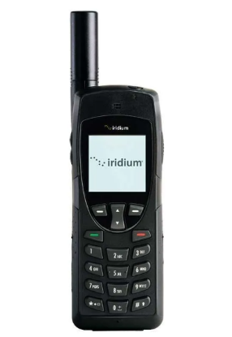
Satellite phones: A reliable way to communicate where cell service is not available.
Work similar to cell phones, but instead of working on traditional cell sites, it connects to the telephone network via satellite. This can provide better reception in areas where traditional cellular coverage is inadequate for reliable conversation. Satellite phones are expensive and require a subscription plan, but may be a great option for frequent or extended off grid communications. Some examples of reputable brands are:
  - Iridium
  - Inmarsat
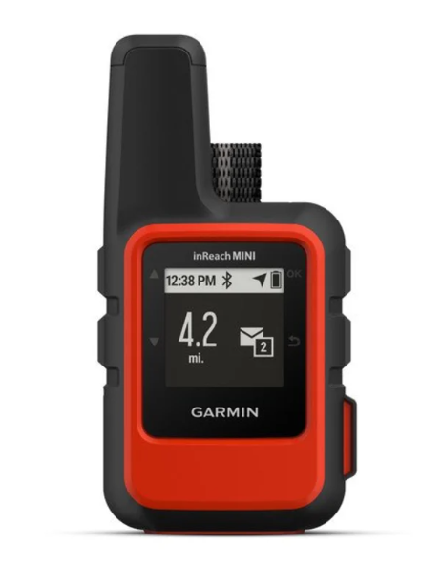
GPS Tracker: Allows for simple messaging and emergency SOS over GPS
GPS trackers use the satellite system so they have service almost anywhere on the globe, and are much less expensive than a satellite phone. They are a great way to know your location and get that location to others, but communication is limited to short texts. Many have options that can alert local Search and Rescue teams or EMS that help is needed, and exactly where that help is located. Depending on the type of GPS tracker, some have the capabilities of two-way text conversations and some can even link to your smartphone via an app and you can use that to text from your phone. GPS Trackers require a subscription plan that can vary in cost depending upon the number and frequency of texts sent per month. Some examples of reputable brands are:
  - Garmin
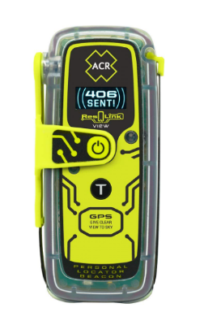
  - SPOT
Personal Locator Beacon (PLB):
PLBs are used in case of an emergency in order to immediately send out a radio signal that is received by local dispatch which then sends EMS and Search and Rescue to the location that the radio signal is emitting from. PLBs do not require a subscription, but do not allow for any sort of one or two-way communication.
The EH&S Office has GPS Trackers that you can borrow if your field activities are small, limited or sporadic. Please visit https://research.usu.edu/ehs/inreach-first-aid-kit-checkout to check out first aid kits and InReach devices.

Important safety equipment to bring to the field
Field work is done away from the normal work areas where supplies and equipment are readily available. Some field sites may only have what you bring into the field with you. The Field Safety Plan must evaluate and develop a list of those things the team cannot survive without (food and water) but also other pertinent safety equipment as well. OSHA requires employers to ensure that safety precautions are in place and that workers will be safe when conducting their jobs. That is not to say that the research conducted may not be hazardous, it just means that when planning your trip, you must be knowledgeable about the hazards you might face and how to protect those who work for and with you. Ignorance is no excuse if someone was to get hurt, and that is why creating the Field Safety Plan is so important. If a worker does not have the proper PPE, does not wear their proper PPE, or does not have protections in place to prevent machinery from harming them, OSHA can take action, especially in the case of a reportable incident (loss of life, limb, or eyesight).
In order to protect yourself, it is imperative that when you conduct your hazard analyses you are also thinking about how to minimize exposure to those hazards, how to minimize risks you are taking, and what PPE is required to protect you from those scenarios. The following lists are just some examples of equipment, PPE, and paperwork that might be pertinent or useful. These lists are by no means exhaustive and should be tailored to your individual trip to ensure that you have all that you need to be safe and successful in your work.

Outdoor Essentials
- First aid kit
- Map, compass, GPS
- Charged cell phone, radios, satellite phone/device or Personal Locator Beacon; extra batteries/charger
- Extra water and/or water purification methods
- Extra food/snacks
- Hats, sunscreen, sunglasses
- Emergency shelter: shade canopy or lightweight tarp, bivy sack, or emergency space blanket
- Appropriate footwear and clothing, layers
- Flashlight or headlamp
- Matches or fire starter
- Leather/work gloves
- Signal mirror, whistle
- Knife or multi-tool; duct tape for basic repairs
- Your field safety plan with emergency procedures, other protocols if applicable
- Other equipment specific to your class or project
- A basic tool kit

Safety equipment to bring in your vehicle
- Extra first aid kit, water, snacks
- Jumper cables, tire gauge, spare tire, jack, tow rope
- Printed map, directions
- Charged cell phone, charger
- Flashlight or headlamp
- Useful supplies: duct tape, super glue, bungee cords, large plastic bag
- PPE: nitrile gloves, grip gloves, safety glasses, reflective vests
- Fire extinguisher, shovel, bucket of water (for work in dry vegetation with any type of ignition source/spark)
- Space blanket, sleeping bag, and/or extra dry clothing (for cold or wet field sites)

Paperwork and forms/documentation
- Relevant permits (scientific collecting permits, animal use protocols)
- Participant medical forms (consult with your campus medical director for guidance)
- Copies of drivers’ licenses, driver authorizations (if applicable)
- Copies of passports for all participants on international courses/trips
- Copies of medical history/prescriptions of participants (if applicable)
- Include a participant list with emergency contacts as part of your field safety plan, dive plan, or float plan

Transportation options and precautions
Fieldwork will require some form of transportation to travel from campus to the field site. The National Highway Traffic Safety Administration (NHTSA) states that travel can be the most dangerous part of any trip. The Field Safety Plan should evaluate the modes of transportation necessary for the field work to assure that each is appropriate and as safe as possible. All persons operating vehicles must be licensed and/or trained in the safe operation of that vehicle. All vehicles must be inspected for safety, certified for their intended use, and insured by USU Risk Management.
The methods of transportation chosen for field work, whether it is for transportation to and from the site, or transportation around the field site are just as if not more important than the equipment you take to the field. If not for the safe transport of yourself and/or your researchers, there would be no field work. That is why it is necessary to make sure that the vehicles you choose are safe, are the correct vehicle for the job, and that everyone knows how to use them. As with all trips and transportation methods, these plans should be included in the USU Travel Authorization Form.
Some potential transportation methods can be seen below:

Not all of these methods are mutually exclusive and it is probable that you will have many different transportation methods in the field. All of these methods, regardless of which ones, must be included in the field safety plan, along with any prerequisite training or required work practices for the field experience.

Potential Field Hazards
Hazard assessment for field activities may be triggered by various entities, such as part of the research safety program, or through department procedures. The field hazard assessment tool below provides an overview of resources and resk mitigation steps for common USU field activities.
ALL field work warrants a pre-trip discussion regarding foreseen hazards, appropriate precautions, communication options, and emergency procedures. Specific actions are listed below.
DESTINATION
□ Is your trip conducted on non-University owned property? | - You may need to complete a travel authorization according to USU Policy 515: Travel
□ Will you be traveling internationally? | - Be familiar with USU Policy 536: International Travel, and follow all required steps
□ Does your “Trip Brief”, the CDC, or State Department recommend vaccinations, prophylaxis, or other medical recommendations for your destination? | - Schedule a medical visit at least 6-8 weeks prior to your trip; USU Student Health Services can assist you with preparation
□ Will you be visiting sites with hazardous terrain, climate, wildlife, zoonotic risks, poor sanitation, other environmental hazards, or remote sites with limited services | - Investigate and understand all potential hazards and risks  - Perform a hazard assessment  - Develop a risk management plan  - Ensure you are prepared to address all foreseen contingencies
□ Does your worksite lack reliable phone service? | - Establish a Primary communications method  - Set Check in frequency and times  - Form an Emergency communications contingency
□ Will you be visiting private property or entering private homes? | - Obtain permission  - Avoid working alone when possible  - Ensure proper approvals/protocols are in place and followed  - Carry USU identification  - Dress comfortably but professionally  - Carry a reliable means of communication and follow communications plan from Field Safety Plan
□ Will you be accessing controlled sites such as construction sites or mines? | - Request PPE and site access requirements in advance  - Carry USU identification  - Avoid working alone when possible  - Check-in with site manager/superintendent to understand what hazards may be present
□ Will you be driving to/at your destination? | - Review USU policies 514 and 515 and follow all requirements in order to drive for USU business Consider off-road/4x4 training if applicable: see USU Policy 539: Off-Highway Vehicles (OHV) Usage
□ Will anyone be chartering boats, planes, or using other non-commercial means of transport? | - Consult with Risk Management regarding appropriate insurance and precautions
PARTICIPATION
□ Are you responsible for students registered in a field course?  □ | - Review Chapter 3: Best Practices for Trip Leaders and Appendix Campus Resources  - Consider establishing a “Student Behavior Agreement” or reviewing a “Code of Conduct”  - Set the tone for a safe trip by discussing expectations and rules before trip  - Carry a participant roster with emergency contact and medical information at all times  - If medical clearance or vaccinations are required, schedule your appointment with Occupational Health at least 6-8 weeks prior to travel (e.g. for use of respirators, working in loud environments, handling bats or other hazardous wildlife).
□ Will volunteers be helping on your project? | - Register volunteers formally;  - See USU Policy 535
Will participants be camping or sleeping in shared tents, dorms, housing, etc.? | - A code of conduct must be developed and agreed to by all participants  - The Code of Conduct must comply with all University policies  - See USU Policies 305, 339, 339A, 339B, and 340
□ Will family members, partners, or other companions be travelling with participants? | - Review USU Policy 515 for family/companion travel
FIELD ACTIVITIES – Specifics to integrate into your Field Safety Plan
□ Working outdoors with temperatures over 80° F or in intense sunlight? | - Carry sufficient water(1L/hour), take breaks in shade  - Carry shades or tarps if natural shade is unavailable  - Maintain means of communication, awareness of worksite location, and ability to obtain EMS  - Reference ??
□ Working in dry vegetation/areas with high fire danger? | - Complete fire extinguisher training  - Carry a fire extinguisher, shovel, and bucket of sand in your vehicle  - Consult with Campus Fire Marshal, local fire district, and/or check local fire restrictions
□ Working in cold/wet conditions? | - Provide all participants a recommended gear list including waterproof clothing, boots; layers for insulation, extra dry socks, tarp, etc.  - Carry extra blankets or sleeping bag in your vehicle for emergencies  - Reference ???
□ Other potential considerations:  - Excavating soil more than 4 feet deep?  - Working at heights over 6 feet?  - Entering caves, vaults, mines, or other potential confined spaces?  - Handling or transporting hazardous material or samples?  - Use of powered tools or equipment?  - Working in loud environments?  - Using OHVs/ATVs?  - Using snowmobiles?  - Clinical work or handling of biological specimens?  - Handling/trapping wildlife?  - Working with electricity? | - Contact EH&S or appropriate hazard assessment, training, and PPE selection  - Including training requirements and precautions in your Field Safety Plan or refer to specific procedures, job hazard analyses (JHA), etc.
□ Will anyone be operating Unmanned Aircraft Systems (drones)? | - Follow applicable Federal regulations
□ Working in, on, or around motor boats, kayaks, canoes, or other watercraft? | - Properly fit PFDs must be worn at all times  - Complete a float plan for every trip

Chapter 2: “What to do when things go wrong”

Incident Response and Reporting
It’s impossible to foresee all of the potential hazards that might lead to injuries or incidents that may occur when working in uncontrolled environments, so as a first line of defense first aid skills can make save a life in case of an emergency. In case of an emergency, having emergency plans in place will help manage situations effectively and potentially mitigate negative consequences. Once a situation is stable and urgent medical care needs are met, report incidents to the Primary or Secondary University Contact to trigger planning of possible University support and evaluation. Reporting procedures, as well as mechanisms to debrief and review incidents are outlined below. As a University, we also comply with a variety of reporting regulations, including but not limited to, reporting of injuries and fatalities, Title IX reporting of sexual harassment and criminal behavior, environmental releases or spills, and loss/theft/misuse of research materials or funds. Related campus-specific policies and resources are listed in Appendix B.
When incidents occur in the field that result in injury to people or damage to equipment, there is a natural human tendency to become “amped” up. Effective incident management can include using the STOP response method – Stop, Think, Observe, Plan. Trip leaders or a designated participant should try to note what the observations and plans were, and then when time permits, these need to be documented to ensure that the appropriate response and/or care is provided to those involved.

First Aid & Initial Response
This chapter outlines established protocols for initial response to an incident, but in no way is it a replacement for maintaining current first aid certification. First aid training includes valuable hands-on practice that cannot be replicated in any other way. Keep your certification current! Refresher training and practice is vital to maintain competency in first aid. Under Utah law, persons who “gratuitously, and in good faith” render emergency care at or near the scene of, or during, an emergency are protected from civil damages and penalties under Utah Code 78B-4-501 Good Samaritan Law. This protection does not protect those that are “grossly negligent” or those who “caused the emergency”. For these reasons only provide treatment within the scope of your training level and never abandon a patient.

Life-Threatening Injuries or Illness
Call 911 or seek medical care immediately. Always know your physical location; everyone in your group should be able to provide Emergency Medical Services (EMS) accurate directions to the field site.

Basic First Aid
By administering immediate care during an emergency, you can help an ill or injured person before EMS arrives. A variety of useful references can also be downloaded to your smartphone (and are accessible without cell or WiFi service) such as the “Emergency Medical Response Guide” from the National Safety Council and “First Aid” from the American Red Cross. Both are available free from the App Store.
EMR Guide – National Safety Council Links
Android: https://play.google.com/store/apps/details?id=com.nsc.hybrid&hl=en_US&gl=US
Apple: https://apps.apple.com/us/app/emr-guide/id1184167315
First Aid – American Red Cross
Android: https://play.google.com/store/apps/details?id=com.cube.arc.fa&hl=en_US&gl=US
Apple: https://apps.apple.com/us/app/first-aid-american-red-cross/id529160691

Seeking Medical Care or Other Support

During Travel
Directions and contact information for nearby medical services should be identified in advance and included in your Field Safety Plan. For International Travel, the US State Department and Embassy websites provide guidance on finding a doctor or hospital while abroad.

Incident Reporting
Immediately report all work-related fatalities, catastrophes, injuries or illnesses to your supervisor and campus department. Supervisors/departments are responsible for promptly reporting incidents to EH&S and Risk Management. Supervisors first report of an incident must be completed online in ServiceNow. Ideally, specific emergency contact numbers and incident reporting procedures are clearly outlined in written Field Safety Plans and carried into the field.

Lessons Learned
By reporting and reviewing incidents among field teams, departments, and with campus staff, lessons learned can benefit a broader group and help improve our operations. We all recognize that injuries happen when working outdoors in uncontrolled environments but want to strive toward being prepared, making safe decisions in the field, and minimizing the negative consequences when incidents occur.
Consider opening these opportunities up to your crew/team and give them the opportunity to add their observations/actions taken to reports. That could allow for improved situational understanding and aid in post trip review/after action reviews (AAR).
Your department safety committee or coordinator, EH&S staff, research oversight committees, or other personnel on campus may be involved in accident investigation and review of lessons learned.

Chapter 3: Resources for Trip Leaders

Best Practices for Trip Leaders
Trip leaders of all experience levels can benefit from these strategies to set the tone for a safe trip and manage situations that arise. It’s impossible to prepare for all scenarios that may unfold when working in uncontrolled environments, but consideration of both objective and subjective factors is critical to manage incidents in the field.

Facilitating Safe Group Decision-Making
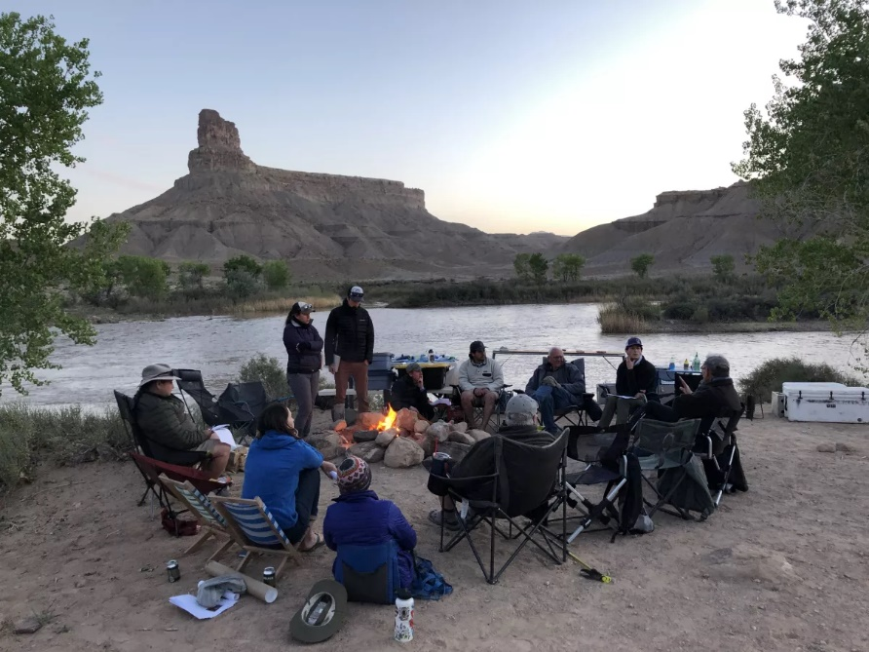
As a field leader, you have to accurately assess risks, mitigate hazards, and carry out safe actions. You also have to facilitate your group making safe decisions together. This can be challenging and requires both competency in risk analysis as well as solid communication and leadership skills. With this in mind, consider the following four ways that groups make decisions:
- Directive: The leader decides and informs the group.
- Consultative: The leader decides after consultation with the group. This can happen two different ways: the leader might first solicit input from the group and then decide or the leader might tentatively decide and get input and reaction from the group before making the final decision
- Group decides: All group members (including the leader) contribute equally to the decision-making process. This could happen through a vote or through consensus.
- Delegation: Leader delegates the decision-making to the group after defining the appropriate boundaries and conditions. Before delegating, the leader must feel comfortable with any decision made.
Many experienced leaders employ all of these decision-making styles depending on the situation and the expertise of their groups. By doing so, the leaders help maintain a safe learning environment while at the same time helping groups take ownership and responsibility for their collective experience.

Effective Communication

Set the tone for a safe learning environment
The success and overall safety of a team is more associated with the quality of its leadership, teamwork, and communication than it is with its overall skill level. Teams don’t magically happen. They are consciously built by the actions of both leaders and participants. Before any risky situations arise, it’s important to develop and practice good teamwork and communication within your teacher/leader team and student/research group.
As a leader/teacher, you have enormous influence over how well (and how safely) your team will perform. Below are several key communication actions you can employ to help you more effectively steer your group in a safe, positive direction.

Establish and maintain reasonable goals, roles, expectations/behavioral norms
As a leader of your group, you have the most influence over creating a culture of safety within your group. By far, the most leverage you have is at the beginning of your class/trip. All of your group’s future endeavors are made easier or more challenging by the effectiveness of these first interactions. Two important meetings should occur at this early stage:
- Meet with your leader/teaching team prior to the beginning of your class/trip to discuss your leadership roles as well as personal and course objectives.
- Facilitate an orientation pre-trip meeting with your whole group as early as possible to establish clear goals, roles, expectations, and behavioral norms.
The following is a suggested format you could use for a discussion about creating a safe learning environment for our employees, students, and researchers participating in a multi-day field project. This discussion should happen as early on in the project as possible. This can easily be modified or shortened for less-involved field experiences or different participants. Regardless, this discussion is one of the key leverage points that leaders have over the general trajectory that their group will follow during their time together. Do not skip it.
SUMMARY:
Communication is key. Two-way communication, understanding group objectives, and each individual understanding how their role accomplishes those objectives allows for successful research trips.
- Introduction: Living and studying outside will pose significant challenges for all of us. A big part of this challenge is how we work together as a group - how we communicate, cooperate, problem-solve and support one another. Field research is different (and much more) than a regular academic experience - we learn together but we also live together and can’t get away from each other when we’re in the field. We have the responsibility both before and during the project to co-create a safe, positive learning environment. The rewards of building and maintaining a safe, supportive community are huge. Your own learning goals will be magnified when we actively work to support each other.
- Explicitly State Leader Expectations: With this in mind, it is important to specify and build consensus around what it takes to maintain a safe positive learning environment. Let’s spend time now as a group discussing this and getting everyone’s input. For now, consider the following general aspects that we as the leaders of this course have found useful in creating a safe positive learning environment:
  - You can expect leaders to instruct, but you can also expect them to respect you for who you are, to support you both physically and emotionally, to give and receive constructive feedback, and ultimately to provide a safe environment for you and the group as a whole.
  - We will expect all of you:
    - To respect one another
    - To practice proactive self-care; check in with us about medical concerns and other concerns you may have
    - To follow our lead & follow the rules
    - To participate fully (be on time, get out of bed, speak up in discussions, take part in activities)
    - To teach and learn from one another (take pride in what you bring to the group and support others in what they bring too)
    - To be open minded and ready to learn (all the time, even when you’re tired, when you’re in the van)
    - To take initiative to try new things (peer leadership)
    - To work together as a team (you don’t have to like everyone, but you do have to work together effectively. Sometimes this means taking a leadership role, sometimes it means supporting one of your peers who takes a leadership role.)
    - To be willing to sacrifice some personal goals for the sake of the group (you may need to speed up/slow down, turn around on a hike, speak up more, listen more, modify your level of sarcasm/joking to fit with the norms of the group, etc.)
    - To give and receive constructive feedback
    - To provide a safe learning environment for everyone
    - To put your whole self into the experience
- Get input from your group: Take some time to discuss in smaller groups anything else the student group thinks is important to maintaining a safe learning environment. Then discuss as a whole group, letting as many participants share what they talked about. Acknowledge everyone for listening and sharing.
- Explicitly go over the important rules: Here are some common rules/issues that you might consider specifically addressing:
  - Personal physical safety - no hiking alone, no rock climbing, swimming guidelines, etc. You must wear your seatbelt in vehicles. You likely don’t have time to discuss all of these right at the beginning, but introducing them lets your group know that you think they’re important. You can say that you will come to these in more detail once out in the field.
  - Emotional safety
    - Sexual harassment: Harassment can include “sexual harassment” or unwelcome sexual advances, requests for sexual favors and other verbal or physical harassment of a sexual nature. Harassment does not have to be of a sexual nature, however, and can include offensive remarks about a person’s sex. The university tolerates zero harassment and as employees, we are mandated reporters.
    - Avoid jokes, sarcasm or insulting remarks: about individuals or groups of people, whether or not they are represented on this course.
    - Aggression: Avoid either verbal threats or motion to harm others in the present or future.
    - Language: Keep things relatively free of bad language.
  - Alcohol and other drugs: This can clearly be a difficult “rule” to establish. Consider bringing up four things with the students: safety, legality, learning and group cohesion.
    - Safety: Clearly drugs and alcohol can compromise safety, which is especially concerning in remote field contexts
    - Legality: Most drugs are illegal and using alcohol or marijuana if you’re under 21 is illegal. Getting caught condoning illegal activities in a university-sponsored field class could cost any leader their job as well as jeopardize the future of the project.
    - Functionality: Drugs and alcohol can interfere with your ability function properly and impair your judgement.
    - Group cohesion: The use of drugs and alcohol can often undermine community building within a group. Often, a smaller subset of a group is most comfortable drinking (or perhaps sneaking off and using drugs) and this leads to cliques and dis-unity.
    - After going after these concerns, you might consider two different rules to establish and maintain:
      - No use of drugs or alcohol
      - Moderate consumption of alcohol only by those of age and only “outside of class time”
    - Consequences: What if they break the rules? Consider saying something like this: “I am ultimately responsible for maintaining a safe learning environment for everyone out here. If your actions aren’t supporting that ultimate goal, I will request that you change your behavior. I can also separate you from this project.”
    - Final advice: If you set and maintain clear expectations, constantly build rapport and connection with your students, facilitate awesome experiences (without drugs/alcohol), and set a good example yourself, you won’t have trouble with this issue.
  - Smoking: Follow the law/rules. In a place where smoking is permissible, smoke outside away from others and throw your butts away (they are not biodegradable). Consider quitting now. Check and follow all local/state/federal fire restrictions.
  - Exclusive relationships (including romantic ones): You might say “Get out of your bubble and be inclusive of everyone.” It takes an explicit, deliberate action to be inclusive of everyone - make it a goal to sit some place different tomorrow and strike up a conversation with someone else. The whole experience will be much more meaningful if we come together as a whole group.
  - Cell phones: “Either put your cell phone in airplane mode or turn it off completely during the day. If there are some apps you’re using, that’s fine. If you want to make brief phone calls, that’s fine as well. What we want to avoid is checking out of the present moment and not interacting with the people who are physically present.”
  - Music: “No speakers in the field; music in the van is at the driver’s discretion. Beware listening too much to music using earbuds: it can lead to checking out too much from the group.”
- Removing someone from the project: You might want to give an example of the rare occurrence where someone might separate from the project. Consider when laying out the ground rules, to list unacceptable behaviors that will cause immediate removal from the project. When:
  - If something inappropriate comes up, we will first and foremost talk with that person or people involved.
  - Our goal would be to build understanding, provide additional support and clarification to everyone involved.
  - However, if the inappropriate behavior continues, we could decide to separate a person from the course.
- Finally, explicitly ask for everyone to follow these guidelines in order to create a safe environment: You might say, “Does all this sound good? Can I get a yes or a nod from everyone? If any of this concerns you, please feel free to come to talk with one or all of us after this meeting.”

Brief your team often
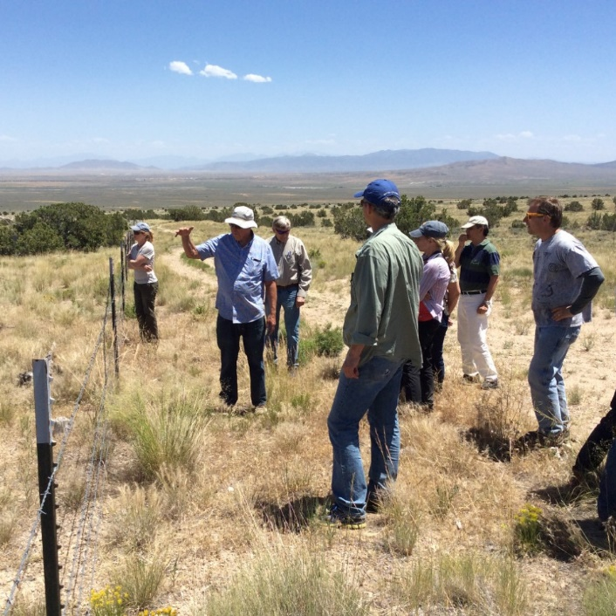
Groups operate more safely when they are frequently briefed on what to expect. Brief at the start of the day or activity. Brief when conditions change. Brief when your plans change. Excellent leaders articulate and explain goals as often as necessary. Strive to incorporate these core ingredients into your briefings:
- Where are we? (What is our location and how do we get out of here in case of emergency?)
- What are we doing? (What are the goals?)
- How are we doing it? (What’s the plan?)
- When are we doing it? (What’s the timetable?)
- Who is doing it? (What are our roles?)
- What hazards can we anticipate?
- How will we manage those hazards? (What are the contingency plans?)
- What gear do we need?
- How and when will we make decisions?
- How is everyone doing? What concerns do you have?
- What is our plan if someone becomes ill or injured or lost?
- Have I been understood? (If necessary, ask your group to repeat back the information you just gave them.)

Practice active listening
The practice of active listening can help you build a healthy group learning community but also can significantly reduce the likelihood of accidents. When you are actively listening to someone, you are supporting people to think out loud. This builds trust, group intelligence, and greater awareness of a situation or issue. It also helps leaders (and their groups) make safer decisions.
Active listening requires that you:
- Be present with your speaker
- Do more listening than speaking
- Make eye contact and use positive body language
- Focus on understanding what someone is saying, not on mentally preparing a response
- Avoid interrupting, debating, and quick, preconceived responses
The two cornerstone skills of active listening are Paraphrasing and Drawing People Out:

Paraphrasing
When you paraphrase someone, you say back to the speaker what you think the speaker said in your own words. This is the most straightforward way to demonstrate to a speaker that his or her thoughts were heard and understood. Though simple, paraphrasing is powerful! When done well, it is non-judgmental and enables people to feel that their ideas are respected.

Drawing People Out
When drawing someone out, ask open-ended non-directive questions. This helps the speaker clarify and refine their thoughts. Setting a tone that invites good listening reduces the probability of accidents.
A good leader sets a tone in which participants and co-leaders feel they can speak up, question and share observations without fear of reprisal. Do this by frequently checking in with your instructor team and student group. Strive to follow these guidelines:
- Give adequate time for discussions to avoid giving the impression that your group has nothing to contribute.
- Make eye contact.
- Listen to your team member’s responses without interrupting or “talking over” them.
- Ask: “Are you getting enough direction from me about what you need to be doing?”
- Be aware giving the impression that you’re really not looking for input.
- Instead of saying, “Okay - you’ve all done this before. Ready to go?,” ask “Hey is anyone not ready?”
- Be aware that silence can be mistaken for agreement. Take the time and create the space for everyone to express their concerns.

Resolving Conflict
The potential for conflict is natural among people and is an inherent part of any group’s development into a safe, high functioning team. Rather than avoid conflict, effective teams manage conflict productively. While conflicts are okay, unresolved conflicts are not. They impede communication and cooperation, and they can lead to incidents. Conflict often arises when expectations, roles and responsibilities are unclear. Participants may be missing information or lack a sense of the big picture. It’s the leader’s job to clarify this for your group. When conflict arises, you should see it as a sign that your team may be unraveling. As a leader, you may need to step in, acknowledge the issue and set aside time to work through the conflict. Do this by listening to the different perspectives and opinions, restating or revising roles & expectations and committing to moving forward productively.
Some strategies to consider:
- Approach the student, co-instructor or team member with respect (think connection before correction).
- “I have been noticing.... and I was hoping to talk to you about it.”
- “I wanted to bring ‘this’ up to make sure you are getting what you need to feel good about this class” or....that you, the other students, and the purpose of this course are all supported.”
- Clarify your expectations and/or goals for the course. If they are not meeting your expectations or hindering your goals, specify which one(s) they aren’t meeting.
- Suggest ways they could meet expectations the next time this situation arises. Don’t be afraid to say: “We need everyone to follow these expectations in order to create a safe learning environment for everyone.”
- Educate your students about the ramifications of their actions, etc.
- Engage in collaborative problem solving with your student(s).
- Make a plan for checking in again.

Addressing student/participant behavior in the field
Often, one of the most difficult challenges of a field instructor/leader is to address group dynamics and individual behavior that can undermine a positive learning environment for everyone. These challenges may manifest as homesickness/disengagement, alcohol or drug use, poor performance, sexist or racist behavior, or various behaviors that prevent inclusion of everyone. Addressing these issues is a continual process and involves all of the following:
- Setting the tone for a safe positive learning environment
- Using inclusive language: (e.g., use “family” instead of “parents”, give students the opportunity to share their preferred gender pronouns when they first introduce themselves to the group)
- Building rapport: Developing positive professional relationships with all students/participants. Give regular positive and constructive feedback, spend time (structured and unstructured) with them, play games, have conversations, ask them questions, set and reinforce boundaries and learn from your students. Make the effort to individually check-in with each of your students/participants at some point during your course/project. Ask them how they’re doing, ask them to give you feedback, and then listen.
Should challenges arise with a student, consider the following options:
- Examine the student’s behavior and their individual experience while revisiting the structure and boundaries you set for a safe, positive learning environment, your role as an instructor and the culture created by your group.
- Are their social dynamics at play in your group that isolate, intimidate, or threaten this student?
- What needs of this student are not being met? What could you do to meet them?
- Is this student getting from his/her disruptive behavior? Is there any other way this student could meet their needs in a more productive way?
- Are the boundaries you have created thwarting this student’s ability to feel capable, connected, and that their presence matters?
- Make structural changes (such as giving more time for lunch, or taking the afternoon off every once in awhile) that you think might alleviate some of the stress on this student.
- Give verbal feedback and coaching first before written documentation.
- Keep a written behavior log of observations about the student’s behavior.
- Be accurate - stick to observations and direct quotes; avoid speculation, interpretation, and evaluation.
- Be specific, clear, and organized. Use dates, times of day, names, etc.
- Use direct quotes from the student and from their peers - “His peers observed him saying ......”
- Be brief and direct
If a behavioral issue does not resolve itself after 1-2 days of trying all of the above, consider creating a Student Performance Agreement (SPA), a structured way to:
- Document behaviors that need to change
- Clarify behavioral expectations
- Outline consequences if change doesn’t occur
An effective SPA should target behavior that is specific, observable and changeable. It needs to include a timeline for change and appropriate consequences.

Appendix A: Training

Training
Mentoring is essential to transfer knowledge and practical skills from experienced faculty, staff and researchers to new researchers and students, and is often provided informally. However, documented training is a critical part of our University safety programs in order to comply with regulatory requirements, accrediting agencies, and in many situations, funding organizations. Commercial trainers typically provide documentation via a certification that an individual should maintain and be able to provide upon request, e.g. a first aid card. USU-sponsored safety training is typically documented centrally on campus, such as through the USU EH&S. Departments, research groups or field course instructors can integrate training on safe practices into lab meetings, hands-on demonstrations, or field lectures, and document completion via a simple sign-in form (template provided below). It is also appropriate to list required training as prerequisites in a Field Safety Plan that is reviewed and signed by all participants. Field-related training typically falls into two categories:
  - Preparation for working at remote sites.
  - Specialized “task-based” training directly relevant to field activities

Leadership Skills
Facilitating field research or teaching field classes can require leadership skills that go beyond the expectations of a lab instructor or classroom teacher. This manual attempts to provide a comprehensive resource for helping instructors learn more of these skills. Many other organizations, both on and off campus, offer much more in-depth training. An excellent written resource is the NOLS Leadership Educator Notebook, which can be ordered from the NOLS store. Field Safety in Uncontrolled Environments (published by the American Association of Petroleum Geologists) also provides excellent guidance on planning and leading field excursions and was the model for USU’s Field Safety Plan template.
- NOLS Wilderness Educator Notebook - https://store.nols.edu/collections/publications/products/wilderness-educator-notebook
- NOLS Risk Management for Outdoor Leaders - https://store.nols.edu/collections/publications/products/risk-management-notebook

Basic Outdoor Skills
Working in the field can require knowledge of many outdoor skills, such as map-reading, compass use, cross-country navigation, camping, cooking over a fire or with a camp stove, field sanitation practices, and treating drinking water. Campus outdoor recreation programs may be able to help provide additional training in these skills or provide referrals, e.g. outdoor skills workshops are offered on many campuses. FIND A LINK TO A PLACE THAT HAS GOOD STUFF THERE

Leave No Trace & Outdoor Ethics
Many field sites are fragile and can easily be damaged by even light use. It’s important, whenever possible, to adopt field practices that minimize lasting negative impacts. The national educational program called Leave No Trace (www.lnt.org) has developed a set of principles that can be generally applied when working in wilderness conditions. More guidelines are available for specific habitats (e.g. river, deserts, etc.) and areas outside the United States on the LNT website and describe how to adhere to the following seven LNT principles:
- Plan Ahead and Prepare
- Travel and Camp on Durable Surfaces
- Dispose of Waste Properly
- Leave What You Find
- Minimize Campfire Impacts
- Respect Wildlife
- Be Considerate of Other Visitors

Specialized “Task Based” Skills
In order to make accurate risk assessments in the field, you need knowledge about specific hazards. For instance, if you don’t understand what causes an avalanche, you can’t possibly accurately decide when, where, and how to safely travel on steep snow. Get the training you need in the specific skill areas where you’ll need to do risk assessment. Even a little training can go a long way towards making more accurate assessments and performing safer actions in the field. Mentoring is critical to transfer knowledge and practical skills from experienced faculty and researchers to new researchers and students. Brief your team often - at the beginning of an activity and as conditions change (effective communication is covered in more detail in Chapter 3). The appendix of this manual will expand with additional technical topics as they are compiled and developed.
Examples of:
Tasks | How to do them
Packing a backpack, REI | https://www.youtube.com/watch?v=jBDido6uX9k&t=313s
How to identify avalanche terrain, Outdoor Research | https://www.youtube.com/watch?v=-4ukZfk0hDY
How to use a compass, REI | https://www.youtube.com/watch?v=0cF0ovA3FtY
What to wear backpacking and hiking in the winter, REI | https://www.youtube.com/watch?v=dN8i454CLv4

Climbing or Working at Heights
Falls from height are consistently among the top causes of work-related fatalities in the U.S.. Climbing trees, towers, or other structures; using ladders or lifts like “cherry pickers”; or other work at height or near edges or cliffs all warrant careful review of equipment and safe practices. Consult with EHS to obtain appropriate fall protection, ladder safety, or equipment training. Full-body harnesses, helmets, and other safety gear must also be properly fit, diligently inspected, and properly used to avoid injuries and ensure compliance with OSHA regulations. Please note: seat harnesses commonly used for sport rock climbing with dynamic (elastic) rope are not acceptable for working at heights because of the potential to be suspended upside down and because they are not designed to absorb shock after a fall as full-body harnesses used in conjunction with shock absorbing fall arrest systems are designed to do. Compliant full body harnesses have a dorsal D-ring to attach fall arrest systems and/or to be used during rescue.

Operating Power Tools or Equipment
In general, consult with your EH&S department prior to using powered tools or equipment (including ATVs and snowmobiles). Follow manufacturer’s instructions and keep a manual accessible. Prerequisites and safe work practices for use of powered tools or equipment should be documented in your Field Safety Plan; in some situations, referring to specific manuals or Job Hazard Analysis (JHA). A JHA is the breaking down of a job into its component steps and then evaluating each step, looking for hazards. Each hazard is then corrected or a method of worker protection (safe practice and PPE) is identified. Additional requirements for worker training, certification, authorization, etc., may be identified for the process or job. The final product is a short, written document, a standard of safe operation for a particular job (see an example JHA).

Excavating or Trenching
Hazards related to excavating or trenching include:
- physical hazards from use of digging equipment or being trapped/buried by collapsing soil
- respiratory hazards caused by disturbing soil that contains Coccidioides fungi (which causes Valley Fever) or other environmental contaminant
- and trips/falls if the edge is not clearly flagged or protected. Excavations greater than 4 feet deep trigger OSHA regulatory requirements for evaluation and shoring. Consult with your EH&S office for guidance and to establish safe work practices

Entering Confined Spaces such as Caves, Vaults, or Mines
Hazards related to entering confined spaces include:
- physical hazards from unstable structural integrity, low overhead clearance
- respiratory hazards from unsafe environmental conditions, such as hydrogen sulfide gas or lack of oxygen
- and increased risk due to access limitations, unreliable communications, and isolated, often dark and rugged/uneven conditions
Consult with USU EHS for confined space entry training and to establish safe work practices. It is a standard precaution for workers to wear a hardhat, headlamp, and carry a 4-gas meter (that measures hydrogen sulfide, combustible gas, carbon monoxide, and oxygen levels simultaneously) to verify safe conditions and adequate oxygen levels prior to entry into a confined space.

Handling Wildlife
Wildlife biologists face environmental hazards in the field, as well as risk of zoonotic and vector-borne diseases and the physical threat of a wildlife attack or bite. During required institutional review of animal protocols, best practices for trapping or darting of wildlife should be adopted, but broader field hazards should not be ignored. As with all fieldwork, working alone, extreme weather conditions, unreliable communications, and limited or delayed emergency medical services may exacerbate any research-related incidents.
It is standard precaution for gloves to be worn when handling any wildlife, and additional controls are warranted for species that transmit life-threatening diseases, e.g. wearing a respirator for handling deer mice (hantavirus), or getting a rabies vaccination for handling bats or other carriers. Animal procedures require hands-on demonstration and training; consult with the USU IACUC and USU EHS for guidance and never perform work that is not specifically approved in your Animal Use Protocol.

Clinical Work or Handling Biological Specimens
Clinical work or collecting/handling human biological specimens should be covered under an Exposure Control Plan that includes careful consideration of vaccinations, safe work practices, appropriate PPE, post-exposure prophylaxis, and incident reporting. OSHA requires that employees that may be exposed to human blood, bodily fluids, or cells be provided Bloodborne Pathogen Training and offered Hepatitis B vaccination at no cost. Consult with USU EHS for guidance.

Transporting Hazardous Materials, Hazardous Waste, or Biological Specimens
Moving regulated hazardous materials can be complex. Most biologicals are not stable for shipping and are typically stored in dry ice or liquid nitrogen. DHL offers a Shipping Dangerous Goods option. World Courier handles infectious materials and replenishes dry ice. They also keep materials in pressurized cabins, and forgo x-rays. Cryoport and FedEx will ship a liquid nitrogen vapor carrier internationally.
Some examples of Regulated Hazardous Materials include:
- Infectious and biological substances
- Genetically modified organisms or micro-organisms
- Chemicals
- Radioactive materials
- Compressed cylinders (whether filled or empty)
- Dry ice
- Liquid nitrogen
- Certain batteries
- Equipment containing batteries (including but not limited to PCs, tablets, cell phones and eVapor cigarettes)
- Gasoline
- Ethanol
Anyone shipping hazardous materials should consult with USU EHS for guidance on required training and labeling. If transporting hazardous materials around campus or from campus to another off-campus location, contact USU EHS for more information. Prior to shipping research equipment or materials out of the country, work with your export control manager or USU EHS to determine whether an export license is required.

Use of Drones
All Unmanned Aircraft Systems (UAS) flights require prior approval and post-flight reporting. https://extension.usu.edu/employee/drones. Please also see FAA Part 107 for more information about commercial drone piloting.

Safety Resources for Specific Areas of Study

Agriculture/Earth Sciences:
- Safety & Health for Field Operations (USGS)

Polar Sciences – US Antarctica Program, Arctic Sciences (NSF):
- https://www.nsf.gov/geo/opp/pehs/index.jsp

Wildlife Biology:
- Guidelines for use of wild animals in research and teaching (American Society of Mammologists)
- Science Guidelines (American Fisheries Society)
- Resources, Collection, & Curation Practices (American Society of Ichthyologists & Herpetologists)
- Precautions for Zoonotic Disease Prevention in Veterinary Personnel (National Association of State Public Health Veterinarians)
- Fish & Wildlife Training Modules (Canadian Council on Animal Care)
- Health Risks for Marine Mammal Works (UC Davis Vet Medicine, 2008)
- Disease Precautions for Hunters (American Veterinary Medical Association)

Archaeology, Paleontology, Anthropology, Others:
- Health and Safety for Museum Professionals (SPNHC)

Working Alone Off-Site (CCOHS Fact Sheet):
- https://www.ccohs.ca/oshanswers/hsprograms/workingalone_offsite.html

Guidelines for Social Worker Safety:
- https://www.socialworkers.org/Advocacy/Policy-Issues/Social-Worker-Safety

Safety of Journalists:
- http://www.unesco.org/new/en/communication-and-information/freedom-of-expression/safety-of-journalists/
- https://www.bbc.co.uk/safety/guides/journalism

USU Field Safety Plan
Field Site Location: | Descriptive name of research location (e.g. Dry Canyon, Logan, Utah)
Activity Description: | Type, length, and purpose of activity (e.g. hiking 3-4 miles, collecting specimens, etc.)
Plan Created for: | Name of Research Group / Course / Trip Leader | Date of revision: | Mo-Day-Yr
Date(s) of Travel: | Start date, duration, expected return to campus

A field safety plan serves as a tool to document your hazard assessment, communication plan, emergency procedures, and training. This plan should identify hazards, as well as precautions and actions taken to address and mitigate those hazards. Instructions:
- Complete this field safety plan: insert specifics for your site and operations, delete irrelevant sections.
- Complete appropriate training for your site and operations (e.g. first aid, heat illness, task-specific training).
- Obtain immunizations and prophylaxis for your destination, if applicable (schedule 8 weeks in advance).
- Hold a pre-trip meeting with your group and/or supervisor to review your field safety plan, travel logistics, pack list (including first aid kit), personal safety and security concerns, and any remaining training needs.
- Register all trips with a Travel Authorization. For travel insurance documentation, location-specific travel alerts via email, and emergency/travel assistance contacts contact Risk Management and the Travel Office.
Site Information
Location | Latitude: XX.XX (from GPS/Map) |  |  | Longitude: XX.XX (from GPS/Map)
Site Information | Elevation, terrain, environment.
Travel to Site | How will participants get to the field site? Note any dangerous roads, conditions.
Site Access | Are there any particular restrictions or challenges to accessing site? Note any alternate routes or suggested parking areas; gate access codes, etc. Make special note if isolated or remote.
Environmental  Hazards | Describe any dangerous wildlife, insects, endemic diseases, poisonous plants, etc. that participants may encounter. Note intended mitigation measures; discuss prior to trip.
Security | High risk for harassment or violence? Note intended mitigation measures; discuss prior to trip. For international travel, check the U.S. State Department travel site for current travel alerts and to look up the security rating for your destination.
No Go Criteria | What are the conditions under which approach to - or activities at - the site should be stopped or canceled? e.g. heavy rains, electrical storms, snow, temperatures > 100 degrees, within 2 hours of high tide, wave heights over 1 meter, etc.  For complex trips, consider using the GAR Risk Management Model.
Expected Weather | Note extreme conditions that could impact the trip or require additional planning, (e.g. high heat, wind, rain, snow, approaching storm).
Drinking Water Availability | ☐ Plumbed water available ☐ Water cooler with ice provided ☐ Bottled water provided  ☐ Natural source and treatment methods (e.g. filtration, boiling, chemical disinfection):
Access to Shade/Shelter | If forecast exceeds 80°, shade must be provided by natural or artificial means for rest breaks.  ☐ Building structures ☐ Trees ☐ Temporary Canopy/Tarp ☐ Vehicle with A/C ☐ Other:
High Heat Procedures | Required when temperatures are expected to exceed 95° F: If possible, limit strenuous tasks to morning or late afternoon hours. Rest breaks in shade must be provided at least 10 minutes every 2 hours (or more if needed). Effective means of communication, observation and monitoring for signs of heat illness are required at all times. Pre-work safety discussion required.  ☐ Direct supervision ☐ Buddy system ☐ Reliable cell or radio contact ☐ Other:
Emergency Services and Contact Information
Primary Contact: Research Site | Name, address & phone #, may be a local colleague/institution, reserve manager, USFS office, etc.  Lodging location: name, address, phone # | Primary Contact: University Site  Not on trip. Provide a copy of this plan. |  |  |  | Name, number, email; may be a Professor/PI, department contact, supervisor back on campus, etc.  Frequency of check ins: daily, at end of work day, etc.
Secondary Contact: Research Site | Name, address & phone #, may be a local colleague/institution, reserve manager, USFS office, etc.  Lodging location: name, address, phone # | Secondary Contact:  University Site |  |  |  | Name, number, email; may be a Professor/PI, department contact, supervisor back on campus, etc.  Frequency of check ins: daily, at end of work day, etc.
Emergency Medical Services (EMS) | Procedures for contacting emergency medical services.
Nearest Emergency Department (ED) | Evacuation plan and transportation options to the nearest Emergency Department; include estimated transport time, contact information and driving directions from the site to the nearest provider of emergency medical care. Attach map with specific directions.
Cell Phone Coverage | Primary Number:  Coverage: good, spotty, none  Nearest location with coverage: |  | Satellite phone/device |  | Device carried? ☐yes ☐no  Type/number:
Nearby Facilities | What facilities are available at or near the site: restrooms, water, gas, public phone, store? If not, where are the nearest services along the route?
Side Trips | Are side trips planned or allowed during free time? Before or after the planned activities? Are there restrictions, specific rules, or expected code of conduct?
Participant Information
Field Team/ Participants | Is anyone working alone? ☐ Yes ☐ No If yes, develop a communications plan with strict check-in procedures; if cell coverage is unreliable, carry a satellite communication device or personal locator beacon.  Primary Field Team Leader: Name, phone number  Secondary Field Team Leader: Name, phone number  ☐ Field Team/Participant list is attached as training documentation  ☐ Other attachment: e.g. course roster
Physical Demands | List any physical demands required for this trip and training/certification provided. e.g. diving, swimming, hiking, climbing, high altitudes, respirators, heights, confined or restricted spaces, etc. (consult with EH&S regarding appropriate training & documentation).
Mental Demands | List any unique mental demands required for this trip, e.g. long travel days, high stress environments, different cultural norms, etc.
First Aid Training  & Supplies | OSHA requires at least one trained person (with current certification) for work at remote sites. CPR also recommended.  List team members trained in first aid and the type of training received.  Location and description of group medical/first aid kit: Who is carrying it, where is it stored. Brief description of contents.
Immunizations or Medical Evaluation | List required immunizations/prophylaxis or required medical evaluation, if applicable.  For travel-related immunizations or medical advice, contact USU Student Health Services (435)797-1660 8 weeks prior to your trip.
Equipment and Activities – Consult with EH&S for specific training and requirements.
Research Activities | Briefly describe the goal of your field operations, e.g. collection of samples, observation of animals/environment, interviews with human subjects, etc.…
Field  Transportation | What vehicles will be used during field operations? e.g. chartered boat, paddle craft, car, ATV, truck with trailer, snowmobile, chartered plane or helicopter, etc.  Policy 514: Vehicle Use Policy  Policy 539: Off-Highway Vehicle (OHV) Usage
Research Tools | Briefly describe tools or equipment that will be used to access the research site or during research activities. Indicate specific training required before use, e.g. sharps (knives, razors, needles), hand tools, chainsaws, power tools, heavy machinery, tractors, specialty equipment, firearms; lasers, portable welding/soldering devices; other hazardous equipment or tools.
Other Research Hazards | Describe other potential research-associated hazards e.g. handling or shipping hazardous materials (chemical, biological, radiation, and explosives), handling animals, climbing or working at heights, rigging; shoring/trenching, digging/entering excavations, caves, other confined spaces; drone use.
Personal Protective Equipment | Required—e.g. boots, safety glasses, PFDs, hardhats, etc.  Recommended – e.g. walking sticks, gloves, long pants, hats, insect repellant, sunscreen
Additional Considerations
Insurance | Consult with USU Travel services and Risk Management for more information regarding vehicle insurance.
International Activities | Check with the USU Travel Office regarding required approvals. Visas, permits, finances, import/export controls, transportation of specialized equipment, and data security must be considered. Contact Risk Management for more details.
Personal Safety & Security | Personal safety risks during free time should be considered and discussed in advance, e.g., alcohol or drug use, leaving the group, situational awareness, sexual harassment, or local crime/security concerns. Review expectations and set the tone for a safe, successful trip.  High Risk Travel:  Check the U.S. State Department travel site for current travel alerts and contact Risk Management for further guidance.
Campus Contacts
USU Police | (435) 797-1939,
Student Health Services | health.usu.edu  (435) 797-1660
EH&S | Field Safety Officer: Michael Dyer – michael.dyer@usu.edu, (435) 797-0929
USU Travel Emergency  Assistance | https://www.usu.edu/risk/international-travel/international-sos  Risk Coordinator: Jarrod Larsen – jarrod.larsen@usu.edu, (435) 797-1844  USU International SOS Membership Number – 11BYSG000002  International Assistant App  Please see USU Risk Management International SOS website: https://www.usu.edu/risk/international-travel/international-sos
Report Injuries | Use USU ServiceNow to report all injuries and near misses to Risk Management and EH&S

Include any additional resources: route/location maps, photos of general terrain and areas requiring extra caution, etc.
Signature of PI/Supervisor:
I acknowledge this safety plan has been prepared for field work under my supervision.

Name | Signature | Date | Phone Number

Field Team/Participant Roster - Training Documentation
I verify that I have read this Field Safety Plan, understand its contents, and agree to comply with its requirements.
Name/Phone Number | Signature | Date | Emergency Contact/Phone Number | List Trainings Completed

USU Field Safety Incident Report
To be filled out ASAP following incident

(Circle One) Incident Near Miss Unsafe Act/Condition

Date _______________________ Reporter Name ________________________________
Reporter Phone _______________________ Reporter Email _________________________________
Project Name _________________________________________________________________________
Incident Date _______________________ Incident Time _________________________
Incident Location ______________________________________________________________________
Landowner ___________________________________________________________________________
Injuries: Yes No Damage: Yes No
Responding Emergency Services/Law Enforcement ___________________________________________

Involved Individuals _______________________________________________________________________________________________________________________________________________________________________________________________________________________________________________________________

Incident Description ____________________________________________________________________________________________________________________________________________________________________________________________________________________________________________________________________________________________________________________________________________________________________________________________________________________________________________________________________________________________________________________________________________________________________________________________________________________________________________________________________________________________________________________________________________________________________________________________________________________________________________________________________________________________________________________________________________________________________________________________________________________________________________________________
Action Taken (First Aid, Emergency Services, Law Enforcement, Hospital, Etc)
_______________________________________________________________________________________________________________________________________________________________________________________________________________________________________________________________
______________________________________________________________________________________________________________________________________________________________________________________________________________________________________________________________________________________________________________________________________________________________________________________________________________________________________________________________________________________________________________________________

Injury/Damage Photos

SAMPLE SAFETY & EMERGENCY PLAN (revised 18 March 2022)

NSF Project: Kashunuk River: Effects of above- and belowground linkages on carbon cycling

Project Dates:

Supervisor:

Crew:

TABLE OF CONTENTS

Project Background Information Page 3

Best Safety Practices for Kashunuk River Camp Page 5
Introduction Page 5
Communications Page 5
Food and Water Page 5
Travel Page 5
Boat Page 5
ATV Page 6
Weather Page 6
Physical Activities and Wild Animals Page 6
Medical Services and Health Considerations Page 6
Emergency Response Page 6
Equipment and Instrumentation Page 6
Chainsaws Page 6
Computer Equipment Page 7
Electrical Equipment Page 7
Hand and Power Tools Page 7
Fuel Safety Page 7

Communication and Weather Protocol Page 8

Boating Safety Plan Page 9

Medical Emergency Plan Page 11

In-Camp Illness Assessment Page 12

COVID-19 Protocol Page 13

Weather/Flood/Fire Emergency Plan Page 15

Additional Emergency and Useful Numbers Page 16

Crew Member Emergency Contact & Pre-Existing Conditions Page 17

Signature Page Page 19

Appendix A: Map and Coordinates of Kashunuk Field Camp Page 20

Appendix B: Polar Field Service In-Camp Medical Kit Page 21

Appendix C: General Float Plan Page 22

Appendix D: Personal Protective Equipment Page 23

Appendix E: Fire /Smoke Reporting Procedures Page 24

Project Background Information

Project: Effects of above- and belowground linkages on carbon cycling

Project Dates: 15 May – 10 August 2022

Supervisor:

Crew:

Project Mission: The part of the project that will take place at the refuge will be a field
manipulation experiment to quantify how the independent and combined effects of grazing, trampling, and fecal deposition by herbivorous geese influence microbial community structure and C cycling. By manipulating the effects of herbivory on wetlands, we will be able to link belowground responses to herbivory with shifts in GHG fluxes and the source-sink strength of the ecosystem. The experiment will be conducted over the summers of 2022 and 2023. We will take almost daily measurements in plots of aboveground biomass, belowground biomass, and CO2 and CH4 flux. We will collect soil samples to analyze microbial community and function.

Location: This project is located in a remote campsite in the Yukon Delta National Wildlife Refuge, Kashunuk River (61.33459ºN, 165.59700ºW). The area includes the river and tundra areas along the lower reaches of the Kashunuk River. We will use snowmachines for early spring put-in or boats for late spring put-in. Daily fieldwork will be conducted by walking or boating to research sites along the coastal fringe (Appendix A).

The nearest town to the field site is Chevak, which is only accessible by boat, snowmobiles or air. Chevak is a small village with limited services.

Transportation: Anchorage to Chevak (approx. ~15 May) by commercial aircraft
Chevak to Kashunuk Camp: prior to breakup – snowmachine, post-breakup – herring boats
Travel for fieldwork by walking and boating

Mission Dates: Mid-May: transport of personnel and supplies to Chevak/Kashunuk camp
1 June – 1 August: fieldwork & data collection
Early August: Camp take-out and extraction of personnel from Kashunuk camp.

Emergency Equipment:
Boat(s): Garmin inReach, satellite phone, float coats, tool kit, paddles, anchor, spare oil, first aid kit, extra food/water on persons
Field: Garmin inReach, satellite phones, first aid kits, (see Appendix B for supply list – provide to medical personnel if needed).

Housing/accommodation: remote campsite, no permanent structures

Communication: | Satellite phone (2) for contacts outside camp, short-range hand-held 2-way radio within camp  Note: cell phones do not work in camp and occasionally in villages  Note: Primary satellite phone turned “on” daily 1000-1200 for incoming calls

Text Only: Device Number
Garmin inReach (checkout) IMEI: 000000000000000
Serial: 555555555
Garmin inReach (personal) IMEI: 000000000000000
Serial: 555555555

Satellite Phone: Iridium 9505A
Primary
Backup

PI Cell Phones:

For all emergencies, contact Alaska State Troopers 907-543-2294

Best Safety Practices for Kashunuk River Camp

Updated March 2022

Introduction
The part of the project that will take place at the refuge will be a field manipulation experiment to quantify how the independent and combined effects of grazing, trampling, and fecal deposition by herbivorous geese influence microbial community structure and C cycling. By manipulating the effects of herbivory on wetlands, we will be able to link belowground responses to herbivory with shifts in GHG fluxes and the source-sink strength of the ecosystem. The experiment will be conducted over the summers of 2022 and 2023. We will take daily measurements in plots of aboveground biomass, belowground biomass, and CO2 and CH4 flux. We will collect soil samples to analyze microbial community and function.
Communications
In case of emergency, contact the Alaska State Troopers and one of the PIs or home institutions via satellite phone (see communication and emergency plans for more details). Communications in the field will be provided by two-way radios with a maximum range of 2 miles, as well as satellite phones for longer trips from base camp. Estimated travel and return times, as well as trip itineraries (i.e., planned stops, destination, routes, alternate routes, etc.) will be established prior to any prolonged travel from base camp. Emergency contact phone numbers will be posted on the door of the main living space.

Food and Water
All food will be shipped through an expeditor from Anchorage before the field season. Produce and perishables will be picked up every few weeks in Chevak. All crew food allergies and dietary restrictions must be taken into account when placing food orders. All crew must fill out an food allergy list prior to food orders. In the field, consumables will be secured in an auxiliary weatherport or cooler in camp. Due to the saline nature of local water sources near the coast, water will be collected as snow and stored in plastic food totes or brought in via herring boat from Chevak. Approximate camp consumption of potable water is a gallon per person per day. We will also have a portable water tank/filter on site as a backup water filtration system in case a sufficient freshwater source is identified.

Travel
Motorized travel at the study site will be by boat, all-terrain vehicle (ATV), or snowmobile. Refresher training for motorized vehicles will be provided at the beginning of the field season, and more extensive training will be made available for personnel without adequate previous experience. It is suggested that personnel wear ear and eye protection when operating motorized vehicles, and personal flotation devices will be supplied to personnel for boating. Severe weather (see Weather) can significantly contribute to difficulty in motorized vehicle operation. In addition, personnel should not attempt to maintain or otherwise modify vehicles without first contacting the PI or site supervisor.

Boat
In the absence of previous adequate state or federal training, field crew members will be required to participate in a Boating Safety class taught by the field site supervisor prior to using boats for any purpose (see Boating Safety Plan).

ATV/snowmobile
In the absence of previous adequate state or federal training, field crew members will be required to participate in an ATV/snowmobile Safety class taught by the field site supervisor prior to using ATVs/snowmobiles for any purpose.

Weather
Weather in this region is extreme. Temperatures can range from cool temperatures in the spring to 80⁰F during the field season, and heavy rains, high (>50 mph) winds, and tidal flooding occur semi-annually. Adequate clothing is essential for working in these environments. We provide personnel expedition tents for working, living, and sleeping in wet environments, and recommend that staff procure waterproof waders or boots. Sun exposure can also be severe; sunglasses and hi-SPF sunscreen are essential to prevent severe eye and skin damage.

Physical Activities and Wild Animals
Physical activities conducted during the project include boating and hiking. Arctic foxes are known to contract rabies if bitten by an Arctic fox seek medical help quickly. Personnel should not attempt to touch or corner wild animals. Bears are rarely observed at the study site (twice during the past thirty years). Moose are increasing in the area and can be an unpredictable threat. As such, personnel will maintain a safe working distance from large mammals. Personnel will be supplied with personal flotation devices for any boating related activities.

Medical Services and Health Considerations
Basic first aid kits and tourniquets will be supplied at field camp and in the boat (Appendix B), and at least one member of the field crew will be trained in cardiopulmonary resuscitation (CPR). Pre-purchasing the majority of our food allows for extreme flexibility with food allergies/intolerance, and epinephrine auto-injectors will be present at the field site. Personnel should be extremely proactive in communicating any known or suspected medical issues as soon as possible (see Crew Member Pre-Existing Conditions).

Emergency Response
Boat access to and egress from camp are restricted by seasonal weather conditions and tidal flows. Careflight helicopters may also be unable to reach camp during periodic severe weather and contact for outside assistance must be made by satellite phone. As such, it is vital that biological personnel are constantly cognizant of personal safety issues, and proactively communicate safety concerns and issues clearly and quickly in order to prevent the need for emergency response.

Equipment and Instrumentation
Work at the field site may expose research personnel to a variety of job-related equipment safety concerns. These include, but are not limited to, chainsaw use, computer use, hand tool use, and electrical equipment (solar panels). Specific recommendations and/or training requirements are listed below.

Chainsaws
In the absence of previous adequate state or federal training, field crew members will be required to participate in a Chainsaw Safety class taught by the field site supervisor prior to using chainsaws for any purpose. Chaps, helmets, gloves, eyewear, and closed-toed shoes are required for operating chainsaws.

Computer Equipment
Prolonged computer use can contribute to musculoskeletal problems for anyone who uses a computer for long hours, including data entry workers and graduate students. When working on the computer for long hours, pay attention to tension, discomfort or pain you feel, and take immediate action to relieve it. Make sure you stand up and walk away from your computer on a regular basis. Just walk around for a few minutes, stretch, and relax. This should be done at least every hour. The greatest risk for these problems occurs when people use computers intensely for long hours and work in poor postures.

Electrical Equipment
Staff must be familiar with operating procedures for equipment, use safety equipment, and be diligent and aware of their surroundings when working with or before approaching electrical equipment. Avoid wiring systems in wet conditions. Miswiring the solar system could result in electrocution or severe burns, however, the system has been set up to minimize operator error. For further details, consult the project renewable power system training video on the lab field computer.

Hand and Power Tools
Camp set-up and maintenance, as well as equipment repair and maintenance, will require the use of a variety of hand and power tools. In the absence of previous adequate state or federal training, or relevant work experience, field crew members will be required to participate in a Tool Safety class taught by the field site supervisor prior to using hand or power tools for any purpose. As a general rule, please do not operate any tools you do not feel absolutely comfortable using, and always notify a co-worker or supervisor when using tools. Helmets, gloves, eyewear, and closed-toed shoes are required for all tool use.

Fuel Safety
Only designated persons shall conduct fueling operations. Smoking and open flames shall be prohibited in areas used for fueling, fuel storage or enclosed storage of equipment containing fuel. Equipment shall be refueled only at designated locations. Liquid fuels not handled by pump shall be handled and transported only in portable containers or equivalent means designed for that purpose. Portable containers shall have tight closures with screw or spring covers and shall be equipped with spouts or other means to allow pouring without spilling. Leaking containers shall not be used. Equipment shall not be fueled or stored near places where gas or fumes might accumulate. Containers shall be examined before recharging and again before reuse for the following: dents, scrapes and gouges of pressure vessels; damage to valves and liquid level gauges; debris in relief valves; leakage at valves or connections; and deterioration or loss of flexible seals in filling or servicing connections. Extra fuels will be stored in leakproof containers stored in a fuel containment area at a safe distance (~100 ft) from the primary housing area.

Communication and Weather Protocol

Daily Safety Check-In
The crew will check-in once daily by texting or calling between 1000-1200 AKDT. This schedule may be adjusted depending on the timing of fieldwork. Any adjustments to check-in times will be communicated 24 hours in advance. The default contacts for camp daily check-ins are PI (phone number) or Co-PI (phone number) unless an alternate contact is pre-arranged. It is the responsibility of the primary contact to organize alternate contacts if they will be away and to relay the new contact information to the field crew prior to their departure.

If Crew does not check-in by the appointed time the following actions will take place:

- The primary followed by secondary satellite phones will be called every 30 minutes and text messages will be sent.

- If there is no response from the field crew by 1700 AKDT, the contact will assess if severe weather is a possible issue by examining local weather data and contacting the refuge for local on-the-ground information. If the weather is deemed threatening, the Alaska State Troopers will be contacted and apprised of the situation.

- If weather is nominal and the field crew has not contacted the designated check-in person for 24 hours, the Alaska State Troopers will be contacted to initiate emergency actions.

Within-Site Travel Check-In
The crew will communicate with each other via hand-held radios, particularly when crew members have used the boat to travel to other sites. They will communicate float plans before leaving and estimated times of return. If they are not heard from one hour beyond the estimated time of return, other members will attempt to contact them with hand-held radios. If the field crew is 8 hours beyond the estimated time of return and cannot be reached via radio, the PIs will be contacted and will respond accordingly.

Weather Protocol
The crew will use the satellite phone to check the NOAA weather forecast every day (907-266-5145; options 2,2,1). Daily fieldwork and boating decisions must take weather predictions into consideration. Crews will also use dual-band, two-way radios to check for NOAA emergency weather updates.

Emergency Contacts (USU)
- PI xxx-xxx-xxxx (m)
- co-PI xxx-xxx-xxxx (m)
- Michael Dyer – USU Field Safety Officer 435-797-0929 (w)
- Safety Representative xxx-xxx-xxxx (m)
- Department Head xxx-xxx-xxxx (w)

Boating Safety Plan

Operation of 18’ Lund with 40 HP motor will be used to move personnel and equipment throughout the YK Delta as well as for resupply in the local village of Chevak. In an emergency, call Alaska State Troopers 907-543-2294.

Training: All individuals operating the boat must attend the Polar Service boat training.

Float Plan: This project requires regular use of watercraft for fieldwork; boating activities are tide dependent. A general float plan is in Appendix C. On days boating will occur, the field crew will file a verbal float plan during the daily check-in. Float plan will include departure time, expected time of return, and location of expected field site(s).

Primary Safety Concerns
Boat operation: The primary concerns with traveling in a remote wilderness setting is the possibility of injury, craft collision, or falling overboard.
Precautions: Boat operators and passengers will wear PFD/Mustang suits at all times. Boat handlers will be familiar with the operation and maintenance of the craft.

- Weather conditions in the Delta are highly variable. Wind and weather inland can be very different near the coast. Call the NOAA weather forecast (1-800-472-0391)
- Check daily tide chart before departing (NOAA – Dall Point)
- If wind speeds exceed 15-20 mph, use extreme caution when going out. If wind speeds exceed 25 mph, DO NOT TRAVEL IN THESE CONDITIONS.
- Be aware of your surroundings at all times. Wind and waves can build quickly.
- Keep an eye out for obstacles and give hazards a wide berth to avoid collisions.
- Drive the boat in a straight line. Take turns wide to avoid shallow bars.
- Accelerate the throttle with a smooth consistent motion. When decelerating, give enough time to slow down in the water.
- Use extreme caution when crossing the main channel. Take breaking waves on the bow and avoid getting broadsided on port/starboard or the stern.
- Always have the GPS unit out and available for navigation. Do not rely on navigational aids to mark the bays/channels.
- Passengers must remain sitting and alert. Passengers must wear PFDs at all times.
- Keep anchor and bowlines tidy and secure during travel. If the anchor chain gets caught by bow waves, stop the boat immediately and secure lines.
- Avoid damaging or catching flotsam in the propeller.
- Be aware of the daily shifting tide schedule. Don’t use shortcut sloughs unless absolutely sure of peak high tide.

In Case of Persons Overboard & Hypothermia
In case of a person overboard, retrieve the victim and get them back in the boat without risking additional harm or exposure to other participants. If the driver goes overboard, passengers must regain control of the boat before helping the victim. In these remote situations, it is critical that more people do not become additional victims.
If an individual falls overboard, yell “man overboard” and keep calm. It is imperative that at least one person keep visual contact with the swimmer until they are safely back on board. If you are a passenger in the boat, continue to point to the person in the water to assist the captain in locating them and call out the proximity of the swimmer to the boat. Listen carefully to the captain’s instructions and move carefully about the boat to keep visual contact. Remember that swift movements and overweighting of a side can cause the boat to capsize. To retrieve the swimmer, approach from downwind or down current from the swimmer. This should help with maneuverability and will help prevent the boat from drifting too close to the victim. Keep the boat at a slow, controllable speed. Once you are close enough to the victim, throw a flotation device, such as a life ring, throw cushion, or throw bag. Remember that overthrowing the swimmer is better than underthrowing. Once the victim has a hold of the line or flotation device, shift the boat out of gear and start pulling them in. Grab the victim under the arms as soon as possible and note that you will likely need to help them back into the boat.
If you fall overboard, keep calm! Leave clothing on: Air trapped inside your clothes may help increase buoyancy. Stay warm: If the water is cold, try to maintain your body heat. If you're wearing a life jacket, cross your arms over your chest and bring your knees up to your chest — keeping your knees together and your ankles crossed. Consider swimming: If you can't get back to the boat, consider whether you can safely swim to shore. It may be best to wait for help if: the current is strong or you're unsure whether you can get to shore safely. Keep calm and listen carefully to instructions given to you by the captain or an appointed person in the boat. Do not try to enter the boat from the back unless directed to by the captain as the motor may still be on.
Exposure or immersion to cold water can lead to rapid hypothermia. Hypothermia can render a patient incapable of helping themselves. Watch out for the ‘UMBLES’. It starts with shivering and loss of fine motor skills (we fumble, stumble, and tumble). Next, cognitive abilities become compromised (we mumble and grumble); decision making and the ability to perform complex tasks becomes impaired and apathy sets in.

After the scene is safe for all rescuers, the first step is to stop further heat loss. Gently place the patient (sitting or laying) in a well-built vapor barrier hypowrap for at least 30 minutes. Wet clothes should be removed but damp and dry clothes can stay on the patient. In addition, apply heat sources to chest, back, and armpits if available, and give high-caloric food, and drink (no alcohol or caffeine). If patient returns to normal (not shivering and feeling warm) and is able to stand on their own and walk, monitor closely for afterdrop from the return of cold blood from extremities to the core.
If patient becomes moderately hypothermic (shivering becomes uncontrollable, violent, and movements become impaired), provide thermal stabilization to stop further heat loss. Keep the patient horizontal (no standing or walking) in a well-built hypowrap. Refrain from giving additional food or drink and evacuate to the closest emergency facility.

Field checklist
- Mustang float coats
- GPS, charged
- Extra batteries
- Satellite phone, charged with emergency contact numbers
- First aid kit & tourniquets (x2)
- Emergency repair kit and tools
- Fire extinguisher
- Shaker tube & bung wrench
- Spare paddle & 2”x4”
- Throw bag
- 5-gallon bucket
- Boat operation manual
- Extra food and water
- Extra change of clothing, in dry bag
- Full 15-gallon fuel tank & 5-gallon auxiliary tank

Medical Emergency Plan

In the event of an emergency requiring care and/or evacuation of one or more personnel, please adhere to the following protocol.

The primary point of care in-camp is the crew lead who has received Wilderness First Responder training. In the event the crew lead is unavailable, all other crew members are trained in first aid/CPR. Wilderness first responder manuals will be available in camp.

Primary in-camp point of care personnel:

In Case of a Medical Emergency
  - Assess the situation and if safe, administer first aid/CPR as necessary (for First Aid Kit contents, see Appendix B)
  - If the emergency is serious contact Alaska State Troopers in Bethel (907-543-2294). Communicate your location, the problem and any pre-existing medical conditions listed for the crew member. The troopers can assist with medical treatment and mobilize evacuation from the field if needed. If in doubt about seriousness of the issue, contact the Troopers.
  - See additional contact numbers if Troopers cannot help.
  - Use Emergency Contacts List to inform PIs of incident as soon as possible.

Medically trained personnel in camp
- Name, Certification (Wilderness First Responder), Cert Expiration Date (01/2022)

Local Clinics and Hospitals
Location  Chevak Clinic | Travel time*  10 min | Location | Phone
Location  Chevak Clinic | Travel time*  10 min | 61.53ºN 165.59ºW | 907-858-7029  907-858-7069
Hooper Bay Clinic | 10 min | 61.53ºN 166.12ºW | 907-758-3500
Y-K Regional (Bethel) | 65 min | 60.79ºN 161.78ºW | 907-543-6395
*Travel time is from camp to care via air and does not include mobilization and travel to camp

NOTE: All employees with work-related injuries are covered by USU Workman’s Compensation and evacuation/medical procedures (except COVID-19 and other communicable diseases).
In-Camp Illness Assessment

Recommended guidelines from the Alaska Public Health Office of Epidemiology regarding illness in camp.

When assessing and monitoring for illness, document times and reassess at 30-minute intervals. Be prepared to read this information to a health care provider if you have to call for advice or instruction. If patient is sent to clinic or hospital, send documentation with them.

Baseline Vitals should include
- Time of Vitals
- Temperature - Normal: 97.6-99.6 F; use a thermometer
- Heart Rate - HR=# radial pulse beats in 15 sec x 4; Normal: 60-100 bpm; Strong, weak, thready, slow, or irregular?
- Respiration Rate - RR = # chest rises in 15 sec x 4; Normal: 12 to 20 bpm; Document respirations without patient knowing you are doing so
- Blood Pressure - BP = assess strength of systolic radial pulse; Strong, weak, or none?
- Level of Responsiveness (LOR) using AVPU:
  - Alert to person, place, time, and event (A&Ox4); Person, place, time (A&Ox3); Person, place (A&Ox2); Person (A&Ox1)
  - Verbal stimuli
  - Pain stimuli
  - Unresponsive
- Skin Color and Temperature (SCTM) – Normal: Pink, warm, dry; Document if skin feels hot and dry, hot and sweaty, cool and clammy, blue, grey, or normal.
- Circulation-Sensory-Motor (CSM) –
  - Circulation: assess distal pulses & capillary refill
  - Sensory: assess by touching fingers/toes and asking if sensation is present
  - Motor: asses by asking patient to wiggle fingers/toes, squeeze hands, push/pull with feet
- Pupils Equal, Round, Reactive to Light (PERRL)?

- Document signs and patient symptoms. i.e., headache, nausea, fever, sore throat, achy muscles. At the first sign of sore throat – gargle with salt water.
- Document allergies/pre-existing conditions
- Document patient last ins/outs

Individual Medication Needs (Prescriptions): Reminders provided to all personnel.

Extra Eyewear (Prescription): Reminders provided to all personnel.

COVID-19 Protocol

Review signs/symptoms of COVID-19, communication options in the field, check in procedures, and emergency procedures. Individuals should have dedicated PPE, provisions, and supplies, if feasible, to minimize sharing. Each person should be asymptomatic for at least two weeks prior to departing for the field. Before leaving, all personnel will be required to isolate for one week and limit contact with others. All will be required to have a negative PCR COVID-19 result within 48 h before leaving (or show a doctor’s note stating they have recovered from COVID-19). Remain aware of local public health requirements and campus policies regarding COVID-19.

General Safe Practices
- Restrict entry to weatherports by off-site guests in order to limit exposure.
- Limit contact with people to well-ventilated locations outdoors.
- Wear a face cover indoors if unvaccinated or when working with youth (not yet eligible for vaccination).
- Wash hands with soap and water frequently for at least 20 seconds.
- Use hand sanitizer when soap and water are not available.
- Cover your mouth and nose with a tissue when you cough or sneeze, or use the inside of your elbow. Throw used tissues in the trash and immediately wash your hands.
- Clean and disinfect frequently touched surfaces.

Supplies & Cleaning
Shared surfaces, equipment and gear should be cleaned and disinfected regularly. Any disinfecting product used should be on the EPA List-N, e.g. Clorox disinfecting wipes, Lysol multi-surface cleaner, Envirocleanse-A, Peroxide Multi Surface Cleaner & Disinfectant.
  - Hand soap
  - Hand sanitizer (> 60% alcohol)
  - Single-use paper towels
  - Disposable nitrile gloves
  - Disinfectant
  - Tissues
  - Extra face covers
  - Carry a thermometer & oximeter in your first aid kit
  - Personal water bottles

Signs & Symptoms
Symptoms may appear 2-14 days after exposure to the virus. People with these symptoms or combinations of symptoms may have COVID-19 and should stay home, monitor symptoms, and call their medical provider:
- Fever or chills
- Cough
- Shortness of breath or difficult breathing
- Fatigue
- Muscle or body aches
- Headache
- New loss of taste or smell
- Sore throat
- Congestion or runny nose
- Nausea or vomiting
- Diarrhea

If someone experiences COVID-19 symptoms in camp, use a COVID rapid test kit to verify. The sick person should be isolated from others immediately. If a person tests positive, the symptomatic patient should:
- Minimize interactions with others
- Be required to wear a mask
- Be kept at least 6 feet from others.
- Sleep in a separate isolation tent with a dedicated sleep kit
- Use a single set of utensils
- Be advised to cough into elbow creases
- Be kept well hydrated

If symptoms worsen or persist, evacuate via float plane to Bethel Regional Hospital (907-543-6395). It is critical to communicate to Bethel Regional prior to arrival that the patient is COVID positive or suffering from COVID symptoms. Seek immediate evacuation to Bethel Regional if the patient has:
- Trouble breathing
- Persistent pain or pressure in the chest
- Confusion
- Inability to wake or stay awake
- Bluish lips or face

Weather/Flood/Fire Emergency Plan

In the event of a Natural Threat emergency please adhere to the following protocol.

Self-evacuation from camp is by boat. The boat should be in a ‘ready-to-go’ state at all times. The boat should always be fueled and contain a satellite phone, emergency water and rations, first aid kits, compass, float coats, and other safety gear. If any incident requires you to leave camp and seek safety elsewhere, contact Alaska State Troopers in Bethel (907-543-2294) followed by the emergency contacts below. Bring warm, waterproof clothing and satellite phones with charged spare batteries.

Severe Weather
Seek shelter in the main weather port, stay dry and use the stove as necessary to stay warm. If weather damages the main port, use additional ports and sleep tents as backup shelters. Travel by boat is not advised unless absolutely necessary.

Storm Surge/Tidal Flood
In case of flood, seek refuge in the boat equipped with emergency supplies. Muster at a centralized camp location (main weatherport), double-check camp personnel via a headcount, and travel inland up the river to higher ground or where flooding is not evident. The inland safety location is the Old Chevak Cabin at the junction of the Keoklevik & Kashunuk Rivers (61.431112ºN 165.45055ºW) or Kanagyak Cabin (Aprun River) (61.36167ºN, 165.12683ºW). If possible, try to prepare for flooding by securing structures and loose items in camp. If there is additional time, retrieve the gas analyzers and get LiCORs to higher ground.

Fire in Camp
In case of fire that cannot be immediately contained and controlled with fire extinguisher (i.e., kitchen fire or gasoline spill), evacuate camp immediately and travel inland a safe distance or to the inland safety location at Old Chevak Cabin or the Village of Chevak. Treat all burns with immediate care. In the event of evacuation meet at muster site and take a headcount. Travel together to evacuation site.

Fire Visible from Camp
If a fire is visible from camp, report and monitor the fire. If fire conditions change, report the change as necessary. See Appendix E for fire reporting procedure. If the fire threatens to reach camp, evacuate camp immediately traveling away from the fire.

Medical Evacuation
- Camp personnel will provide basic first aid and contact the Alaska State Troopers (1-800-811-0911) in case of serious medical emergencies and evacuation. For the content of the field first aid kits, see Appendix B. In case of evacuation that does not include medical emergency contact Coast Guard first.
- Notify Initial Emergency Contact list (see below) to inform of the issue and for further instruction. If contact cannot be made immediately, then notify the applicable option in the Secondary Emergency Contact list (see below). Notify Polar Field Services of any major incident within 24 hours if possible.

Initial Emergency Contacts
- Alaska State Troopers, Bethel 907-543-2294 or 800-478-9112
- Rescue Coordination Center 1-800-420-7230
- US Coast Guard Search & Rescue 1-800-478-5555

Secondary Emergency Contacts
- PI xxx-xxx-xxxx (m)
- co-PI xxx-xxx-xxxx (m)
- Michael Dyer – USU Field Safety Officer 435-797-0929 (w)
- Safety Representative xxx-xxx-xxxx (m)
- Department Head xxx-xxx-xxxx (w)
- Science Project Manager xxx-xxx-xxxx (m)

Additional Emergency and Useful Numbers

Public Safety: | Alaska State Troopers, Bethel  Alaska State Troopers, Statewide  Bethel EMS | 907-543-2294  907-269-5740  907-543-3781
Tribal Organizations: | Chevak Tribal Council  Hooper Bay Sea Lion Corporation | 907-858-7428  907-758-4415
Clinics/Hospitals: | Chevak Clinic  Hooper Bay Clinic  Y-K Regional (Bethel) | 907-858-7029  907-758-3500  907-543-6395
Safety/Rescue: | Coast Guard Search and Rescue | 800-478-5555
 | Rescue Coordination Center | 800-420-7230
Aircraft: | Papa Bear Adventures  Ptarmigan Air | 907-545-1155  907-543-5275
Weather Forecast: | NOAA | 907-266-5145  (options 2,2,1)
Y-K Delta Refuge: | Main Office (M-F, 800-1630) | 907-543-3151
 | Boyd Blihovde (Manager)  Ray Born (Deputy Manager)  Spencer Rearden (Wildlife Biol.)  Ty Benally (Ranger)  Robert Sundown (Pilot) | 907-543-1002  907-543-1003  907-543-1023  907-543-1004  907-543-1007

Crew Member Emergency Contact &
Pre-Existing Conditions/Medications/Allergies

Name
Primary contact: contact name
Phone: (cell)
(home)
Email:
Address:
Any food/medical allergies or health concerns: None
Prescription medications and instructions: None

Signature Page

By signing below, you acknowledge that you have read, understand, and approve of the safety plan for this project. If you will be in the field, your signature also represents your agreement to follow the guidelines and protocols laid out in this plan.

Primary Investigator: ____________________________ Date: ___________

Co-Principal Investigator: __________________________ Date: ___________

Co-Principal Investigator: ________________________ Date: ___________

Project Manager: __________________________________ Date: ___________

Post-Doctoral Researcher: _________________________ Date: ____________

MS student:_____________________________________ Date: ____________

MS student: __________________________________ Date: ____________

Michael Dyer, USU Field Safety Officer __Michael Dyer __________ Date: __3/21/22__

Department Head: ________________________ Date: ____________

Appendix A. Map and Coordinates of Kashunuk Field Camp

Coordinates: approximate (61.321006ºN 165.573472ºW).

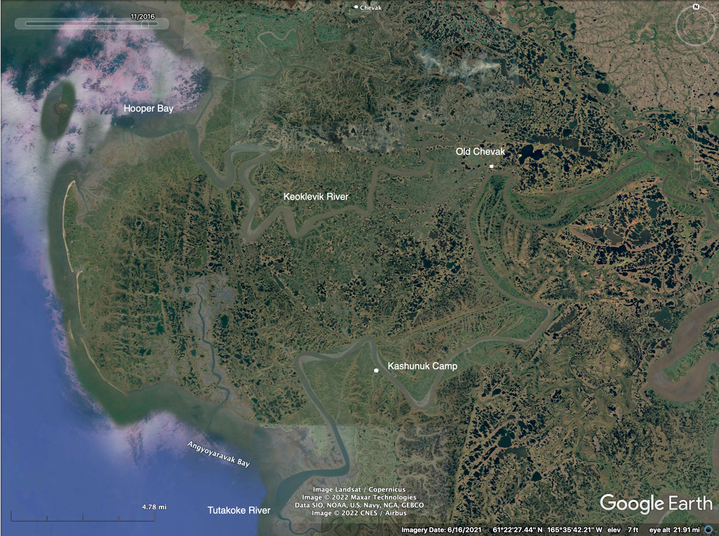

Appendix B. Polar Field Service In-Camp Medical Kits

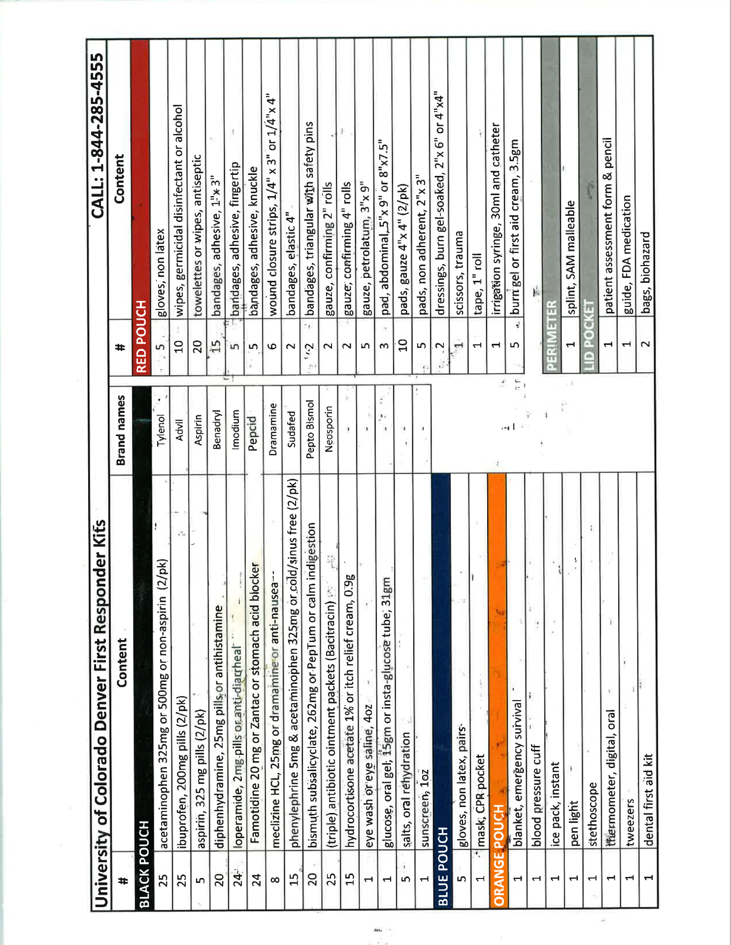
Appendix C. General Float Plan

- Name of Operator and Telephone Number TBD___

- Description of Boat:
Type: Aluminum Open Skiff Color: Silver Trim Color: Red Make: Lund
Length: 16-18 Name: N/A Registration Number: None

- Type of Vehicle Used: None_______________________________________________________

- Purpose of Trip
Travel around camp following breakup

- Persons on Board: Names, Ages, Address
TBD

- Radio Equipment and Frequencies
TBD

- Communication Schedule
An updated float plan will be conveyed to office contact via satellite phone or Delorme text each morning prior to boat crews departure from Kashunuk Camp; crew leader will text office contact each evening upon arrival back at Kashunuk Camp.

- Departure Date and Time: variable, depending on tides and weather______________________

From: breakup To: 15 August
Routes and Stops
TBD.

- Time of Weather Briefing: morning of boating_________________________________________

- If not returned by (date and time): evening of boat trip, call the Coast Guard or Notify the following:
- PI xxx-xxx-xxxx (m)
- co-PI xxx-xxx-xxxx (m)

Boats are used on a regular basis for this project. This is a general float plan for vessel and contact information. A current float plan will be conveyed to our daily office check-in contact on the day of boating activity.
Appendix D. Personal Protective Equipment

Designated to Check All Personnel Are Provided: Project Manager

Flotation, Coats, Vests Etc.: Floatation coat or vest provided for each person. Watercraft
To be worn at all times when in watercraft and wading unfamiliar, deep or swift waters. Float planes
Wading

Hip Boots/Chest Waders: Worn as appropriate to the situation. Wading
Watercraft
Float planes

Chaps: To be used when operating the chainsaw Woodcutting

Safety goggles/glasses: To be used when sawing, hammering, or handling | Carpentry
hazardous materials | Woodcutting
 | Field lab

Ear Protection: To be worn when operating or Outboards
traveling in aircraft and watercraft or working around loud machinery. Aircraft
Ships
Woodcutting

Bug Protection Jackets: Recommended. Insect areas

Helmets/Gloves: Provided. ATV's
Snowmobiles
Woodcutting

Appendix E. Fire /Smoke Reporting Procedures

Contact: (Protecting Agency listed below first, then Refuge FMO or AFMO):

Yukon Delta NWR (south of the Yukon River)
DOF Matsu/McGrath Area (MSS/SWS) Fire Reporting (907) 524-3366

Yukon Delta NWR (north of the Yukon River)
AFS Galena Area (GAL) Fire Reporting (907) 656-1222 or (800) 237-3633

General Fire reporting in Alaska is 1-800-237-3633

Size-up the fire; include items listed below:
- Your Name
- Your telephone number or contact information
- Your location and direction of the smoke
- Location of smoke or fire and best access route (approx GPS Coordinates, landmarks)
• Color of smoke
• Size
• Types of fuels involved and in the vicinity (spruce forest, grass, brush, etc.)
• Fire behavior (running, smoldering, torching, etc.)
• Is anyone fighting the fire?
• Was any person seen in the vicinity or leaving the area? Is there any other information about the origin?
• Current weather conditions at the fire (wind speed, direction, clouds, etc.)

