USER INSTRUCTIONS - GARMIN inReach Devices

Note: EH&S has two devices. One inReach Mini 2, and one GPSMAP 66i. Some instructions below are specific to one device or the other. Reach out to the EH&S office or Field Safety Officer for questions. Garmin support is also available. Below are additional links to operational manuals for these devices.
InReach MINI 2 Owner’s Manual: inReach Mini 2 Owner's Manual - Introduction
GPSMAP 66i Owner’s Manual: GPSMAP 66i Owner's Manual - GPSMAP 66i
Our Garmin Plans Include:
- Unlimited SOS
- 150 Text Messages per month
- Unlimited “Check-In” messages per month
- Unlimited Tracking at 10 Minute Intervals or more

Field User Responsibilities
- Request In-Reach Checkout. Ensure you’ve completed the checkout form online and have received an email of approval from the Environmental, Health and Safety office.
- Coordinate with the EH&S office or Field Safety Officer (sierra.mcbride@usu.edu) for a checkout date/time and place for pickup/return.
  - The Field Safety Officer will email you a confirmation of user setup with details on username and password to log into the Garmin Explore app.
- Arrange pick-up day/time. Call or email Field Safety Officer (435-797-1750 or sierra.mcbride@usu.edu)
  - Pick up location: 1330 E. 700 N., Logan UT 84322
- Upon pickup, ask questions regarding how to use the satellite communication device or how to set it up. We can walk you through it in person at your request.
- Be sure to add at least two contacts directly on the device in case your cellphone battery dies. This ensures you have contacts (one primary and one backup).
- Make sure to FULLY CHARGE the device before heading out in the field. It is wise to bring a back-up battery charger/charging bank during daily field activities.
- Ensure that you return the device on the day agreed upon, in fully working condition with minimal wear & tear.
  - Drop off location: Same as pick-up location.

To Set-up and Sync with Mobile Phone
      - Download the “Garmin Explore” mobile app from an app store on your cell-phone.
        - Open the app.
        - Agree to Garmin’s terms.
      - Log in to the app using username and password that Field Safety Officer provided you.
      - Turn on Bluetooth on your cell-phone.
      - Go to the settings in the Garmin device and turn on Bluetooth.
      - Go back to app on cell-phone > click on devices icon at bottom of screen.
      - If the device you are using is not listed, click the + symbol to add a new device.
        - Select Your Device type (GPSMAP – 66i or inReach Mini 2)
        - Sync will automatically complete when you do this.

REVIEW:
Review the Privacy Policy, Terms and Conditions for Garmin Subscription Services, and Service Terms for inReach Professional Service Plans.
OTHER INFO:

FOR INTERNATIONAL TRAVEL:
If you are travelling outside of the US: It is important to review the restrictions for satellite communication devices for the specific country you go to in order to avoid issues for using or carrying an inReach satellite communication device. Your travel destination may have recently changed its laws or policies for various reasons.
Please review the Countries Where inReach Devices May Be Regulated, Prohibited or Embargoed | Garmin Customer Support.
TO VIEW MapShare:
Supervisors, Friends and family can follow you on the map by going to USU Researchers (garmin.com) or type share.garmin.com/FieldResearch into their browser. This is our personal Map showing waypoints and tracking for EH&S satellite devices. You can view a specific user’s map by choosing their group and user information on the left-hand side.

USING THE GARMIN FEATURES ON THE DEVICES (not on App):

For the GPSMAP66i
Messages
The GPSMAP® 66i device sends and receives text messages using the Iridium satellite network. You can send messages to an SMS phone number, an email address, or another device that uses inReach technology. Each message you send includes your location details where allowed.
Sending a Preset Message
Preset messages are messages that you created at explore.garmin.com. Preset messages have predefined text and recipients.
- From the Messages page, select Send Preset.
- Choose a preset message, and press ENTER.
- Press ENTER to send the message.
Sending a Text Message
- From the Messages page, select New Message.
- Select an option:
  - To start with a pre-written message, select Send Quick Text.
NOTE: You can add and edit quick text messages on the Garmin Explore™ website.
  - To write a custom message, select Type Message.
- Choose recipients from your contacts list, or enter a recipient's contact information.
- After you have finished your message, select Send Message.
Replying to a Message
- From the Messages page, select a conversation.
- Select Reply.
- Select an option:
  - To write a custom message, select Type Message.
  - To start with a pre-written message, select Send Quick Text and select a message.
- When you have finished your message, select Send Message.

Checking for Messages
When you send a message, your device listens for replies for 10 minutes. The device also checks for new messages every hour. When you are using the inReach® tracking feature, your device automatically checks for messages at your tracking interval.
NOTE: Your device must be in view of a satellite at the time of the listen to receive messages.
You can force a check for messages by manually checking for messages, sending a message, or sending a track point. During a check, your device connects to satellites and receives messages waiting to be sent to your device.
From the main menu, select inReach Utilities > Mail Check > Check Mailbox.
Tracking
Starting Tracking
- From the main menu, select Tracking > Start Tracking.
NOTE: Starting the Tracking feature also starts the recording controls.
Stopping Tracking
- From the Tracking page, select Stop Tracking.
Sharing Your Tracking Page
You can share a link to a tracking webpage with other people. The system automatically adds text, including link information, to the end of your message.
- Press MENU twice to open the main menu.
- Select Tracking > Share With > Share.
- Select To to choose recipients from your contacts list, or enter each recipient's contact information.
- Select Send Message.
SOS FUNCTIONS
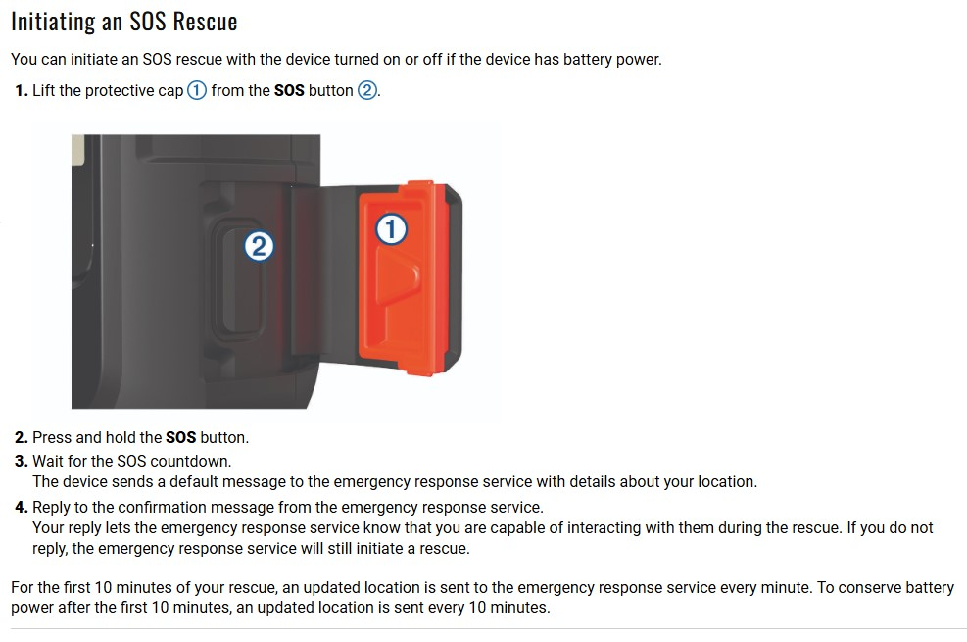
Ensure you have a clear view of the sky when using the SOS function, because this feature requires satellite access to operate properly.
Sending a Custom SOS Message
After pressing the SOS button to initiate an SOS rescue, you can reply with a custom message using the SOS page.
- From the main menu, select SOS > Reply.
- Select Type Message to compose a custom SOS message.
- Select Send Message.
Your reply lets the emergency response service know that you are capable of interacting with them during the rescue.
Canceling an SOS Rescue
If you no longer need assistance, you can cancel an SOS rescue after it is sent to the emergency response service.
- Lift the protective cap, and hold the SOS button.
- Select Cancel SOS.
- When prompted to confirm your cancellation request, select Cancel SOS.
Your device transmits the cancellation request. When you receive a confirmation message from the emergency response service, the device returns to normal operation.

For InReach Mini 2
Messages
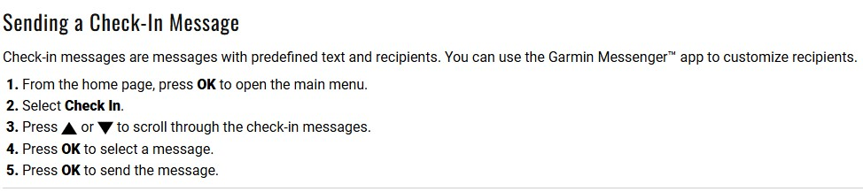
Sending a Check-In Message

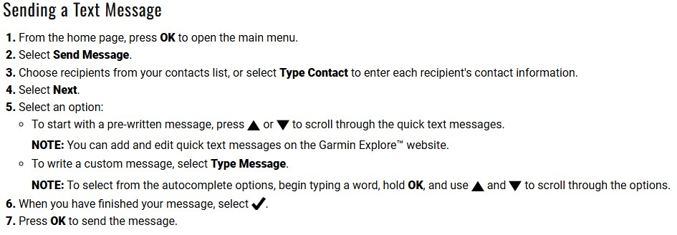
Sending a Text Message

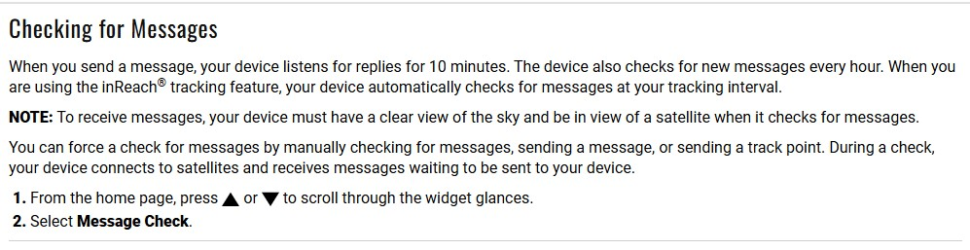
Checking for Messages

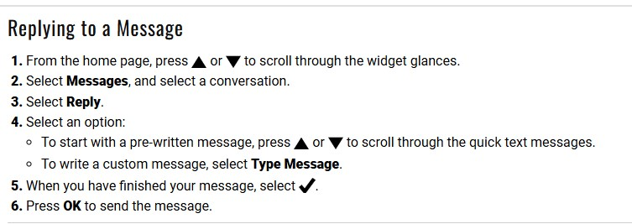
Replying to a Message

Contacts (recommend adding via app or online account rather than on the device itself)
Adding a Contact directly on the device
- From the home page, press OK to open the main menu.
- Select Contacts > Add Contact.
- Select an item to edit (first name, last name, phone number, email, inReach Address) and Enter the new contact information.
Note: Use the up and down arrows and the OK button to choose and edit each item. Then choose the checkmark to accept what you’ve typed out and it will return you to the list of items to edit. Once you have input information into the desired items, select DONE to return to contacts. Then use the return arrow to get out of Contacts, back to the main menu.
InReach Tracking
Starting Tracking
- From the home page, press OK to open the main menu.
- Select Start Tracking.
Your track appears on a tracking webpage/MapShare for friends and family to follow your trip. Starting the tracking feature also starts recording your path as an activity.
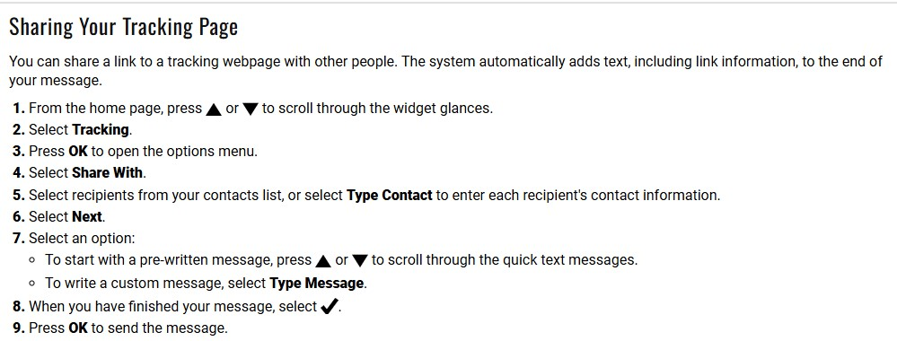
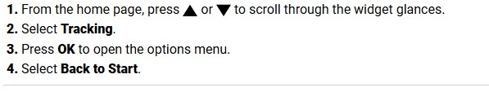
Navigating to the Start of Your Current Track

SOS EMERGENCY FUNCTIONS
During an emergency, you can use the inReach Mini 2 device to contact the Garmin Response center to request help. Pressing the SOS button sends a message to the Garmin Response team, and they notify the appropriate emergency responders of your situation.
You can communicate with the Garmin Response team during your emergency while you wait for help to arrive. You should only use the SOS function in a real emergency situation.
NOTE: Ensure you have a clear view of the sky when using the SOS function, because this feature requires satellite access to operate properly.

Canceling an SOS Request
If you no longer need assistance, you can cancel an SOS request after it is sent to the emergency response service.
- Lift the protective cap, and hold the SOS button.
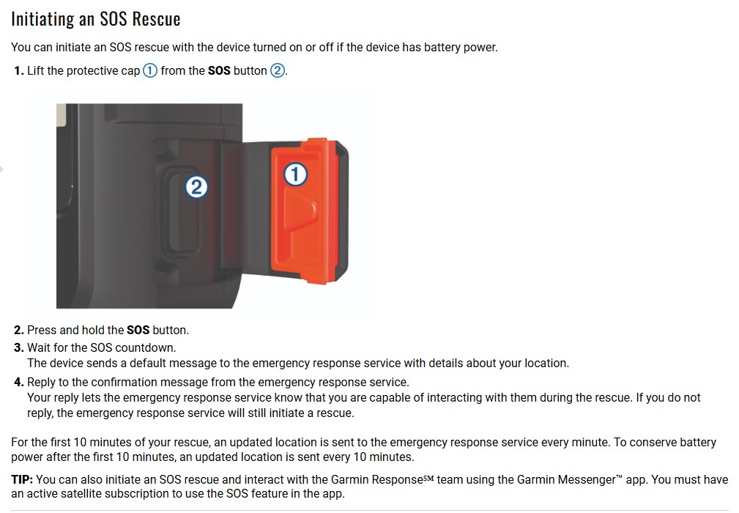
- Select Cancel SOS.
- When prompted to confirm your cancellation request, select Cancel SOS.
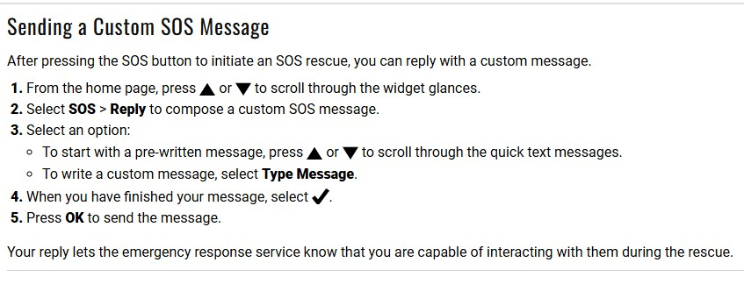
Your device transmits the cancellation request. When you receive a confirmation message from the emergency response service, the device returns to normal operation.

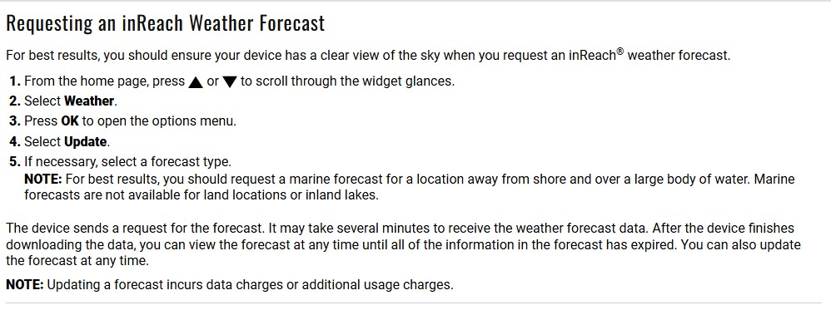
Weather

To add new contacts from “Explore” mobile app for either device
- Log into the Garmin Explore app.
- Ensure that you already completed the “Set-up and Sync” steps.
- Click on the person icon at the bottom-right of the screen.
- Choose “Explore Contacts”.
  - This will show all the contacts currently available to send messages to from the satellite communication device itself.
- Click the orange + button at the top-right side of screen.
- Select “Create New Contact” to fill in new contact information.
  - The “Import Phone Number or Import Email” options let you upload a contact (or email) from your cell-phone to the Garmin Explore app, and then be able to sync the contact to the device itself.
  - Do not use the “Import System Contact” option (importing from your personal phone).
- Contacts that you add and save will still need to be synced to the device.
- Click on the devices tab at the bottom of the app.
- Click on the device you have checked out.
  - Make sure the device is turned on, in range, and has Bluetooth turned on.
  - Click on the device name and it will begin to sync the updated contacts to the device.
- You have now successfully added new contacts and synced them to the device.

To Add New Contacts via Explore.Garmin.com for either device
- Navigate to explore.garmin.com in a web browser.
- Sign in > enter email address and password that Field Safety Officer emailed you.
- Click on “Groups & Users” at the top.
- Choose your Group name (Field Researchers) on the left-hand side under where it says “all users”.
- Then, select the name of the user you would like to update the contacts for.
- Next, Click on “Contacts” at the middle-top of page.
  - You will be able to see the contacts that are currently viewable on the Satellite device and app.
- Click on the “Add” button for you to add new contacts for this user.
  - You do not need to enter in an inReach Addr.
- SAVE.
- Now go to your cell-phone and get into the Garmin Explore app.
- Click on devices at the bottom of your screen > choose your device.
- Turn on Bluetooth on the device and on your phone.
- Click the device name to begin the sync.
- Once sync is complete, you should now have the contacts updated and available for use on this device.

To Edit Preset and Quick-text messages (only Group Admins can do this) for either device
- Navigate to explore.garmin.com in a web browser.
- Sign in > enter email address and password that Field Safety Officer emailed you.
- Click on “Groups & Users” at the top.
- Choose your Group name on the left-hand side under where it says “all users”.
- Select the name of the user you would like to update the Preset and Quick-text message content for (you need to update these on the user that is assigned to the device in order for the device to show the updated message options).
- Choose the “Messages” tab at the middle-top of the screen, between inbox and contacts.
- You can view and edit the preset and quick text messages to your liking.
*Remember that:
Preset messages: These messages already have contacts to notify attached to the messages. When you choose to send a preset message, you cannot update who it is being sent to. To change who preset messages are sent to, you must edit them on the online portal.
Quick text messages: If you choose to send a “quick text” message, at the time of sending the message you determine who the message is sent to. For quick texts, you still need to determine what the messages say ahead of time and modify what they say through the online website.
  - IMPORTANT: Any received messages, including replies to Preset, Check-in, and Quick Text Messages, will count against your monthly satellite message allotment.
- Once you have updated the preset and quick-text messages to your liking, you will need to sync them.
- Turn on Bluetooth for cell-phone and turn on Bluetooth in Garmin device > Open the Garmin Explore app > Sign in > Click devices icon at bottom > Choose your device > Select the device name to begin the sync.
- Sync will automatically put the messages you updated online directly into the Garmin device for use.
- You’re done!
NOTE: On both the GPSMAP66i and the inReach Mini 2, the users can also add contacts on the device itself. It will let you add and save them. These contacts will show up on the online profile and on the app once the device has been synced. EH&S will factory reset devices between users.

