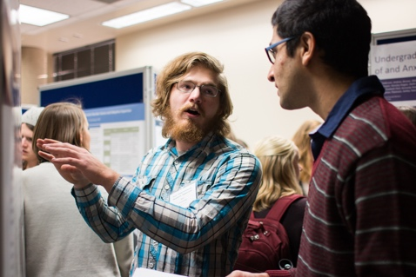
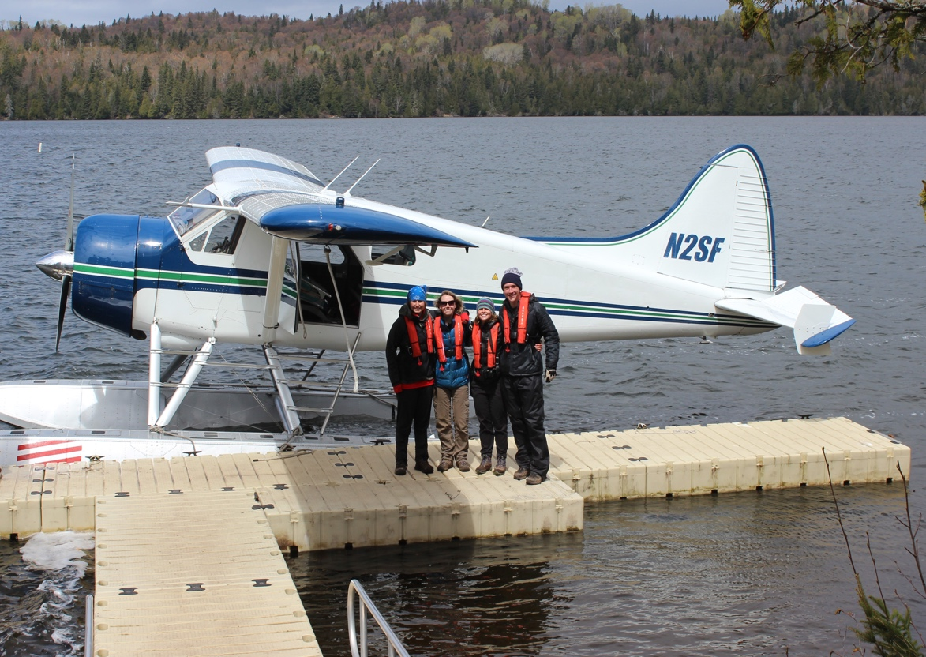
  Undergraduate Research Fellows
    - Semester Updates
    - Spring 2018
a survey of our fellows’ achievements in Fall 2017 |  | In This Issue

There are 86 active URFs on Campus for Spring 2018. You come from every college at USU, and have a combined total of 108 majors and 53 minors!
During the last term, however, this looked a little different. There were 44 major or minor changes just last term.
Congratulations to those of you who received grants to fund your research:
- 3 of you earned URCO grants
- 4 of you earned QCNR grants
- 2 of you earned EURP grants
- 1 of you earned a CHASS grant
And, a great number of you have already shown or will soon be showing your research at presentation events here at USU:
- UR orientation (1 fellow)
- 2018 Spring Runoff Conference (1)
- Hansen Life Sciences Retreat (1)
- Citizen Scholar Conference (1)
- Fall Student Research Symposium (3)
- Institute of Biological Engineering Conference (2)
- Biology Undergraduate Research Symposium (1)
- SELECT Annual Meeting and Technology Showcase (1)
- Utah Conference of Undergraduate Research (7)
- Research on Capitol Hill (7)
- National Conference of Undergraduate Research (6)
- Ignite USU (2)
But that’s not all! More of you presented around the country:
- Rocky Mountain Psychological Association Conference, Salt Lake City UT
- The Wildlife Society’s 2017 Annual Conference, Albuquerque NM
- GNU Radio Conference, San Diego
- Asilomar Conference on Signals, Systems, and Computers, Monterey CA
- Rocky Mountain Section American Society for Engineering Education, Provo UT
- Algae Biomass Organization Annual Summit, Salt Lake City UT
Finally, an early congratulations to the 9 of you that will graduate in May 2018!
Presentation Opportunities

Our Fellows: A Snapshot

A critical part of research is disseminating your results to the broader community. This year, fellows presented or will present throughout the US!
Page 3
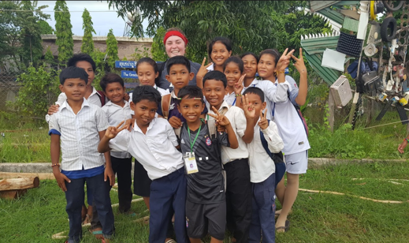
Summer Activities
When you’re not in class, you’re out in the world making a difference, from internships and summer research to humanitarian and service projects world-wide.
Page 5


Publications

Publishing your research is a phenomenal accomplishment as an undergraduate student. This year, we have two fellows who have had their work published in academic journals!

First, congratulations to Dana Sorensen, a junior fellow in Computer Engineering. His publication, Time and Frequency Corrections in a Distributed Radio Network Using Gnu Public Radio, is published in the conference proceedings of the 2017 GNU Radio Conference. His work looks at the process of analog to digital converting and how using software feedback loops can compensate for the synchronization problems in most low-cost conversion methods.

Second, congratulations to AJ Walters, a senior fellow in Biological Engineering. His publication, Qualitative Analysis of Microbial Dynamics during Anaerobic Digestion of Microalgal Biomass in a UASB Reactor, is published in the International Journal of Microbiology. His research focuses on the anaerobic digestion of microalgal biomass on municipal wastewater.

Publication Goals
Some disciplines encourage undergraduate publishing, while others offer fewer opportunities to do so. However, there are a number of journals that focus on undergraduate work across disciplines, so this is an achievable goal for all! Look through the website below to find a good fit for your research.

Council on Undergraduate Research
https://www.cur.org/resources/students/undergraduate_journals/

Putting in the Hours

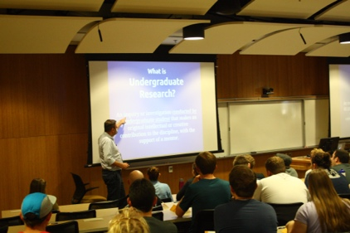
This is the first time we’ve asked you to estimate how many hours you put into your research per week. As time goes on, we’ll be able to estimate to incoming fellows the range of time commitments that their research may require of them, from looking at averages by year in the program to discipline- and even mentor-specific averages!
Impressively, your cohort has reported an estimated 5 hours per week, or a total of 7,104 hours of research in Fall 2017!
Senior Tyler Gardner, Mechanical Engineering, says: “While many say that getting involved early is important, I would say that being diligently involved is even more important. If you can put forth consistent effort, it is easier to achieve long-term goals and plans. Otherwise, you end up burning the midnight oil in spurts trying to meet a deadline that blindsided you.”
*53 of you worked for a professor on their research
*30 of you worked on your own projects
*12 of you applied for research funding
*14 of you presented your research

You’re also students, first and foremost. You had an impressive average GPA of 3.82 for fall, bringing your total average to 3.85!
That’s a lot of hard work. Take the advice of senior Ben Lovelady, in Physics:
*Don’t think that just because “you’re an introvert” you don’t need a social life
*Don’t learn class material before you take the class, else you will do really poorly in the class because it is so boring
*Yes, you can get headaches from thinking. Try to have a few days a week where you don’t induce them. It can build up negative associations with your work, and be another motivational hindrance

Presentation events
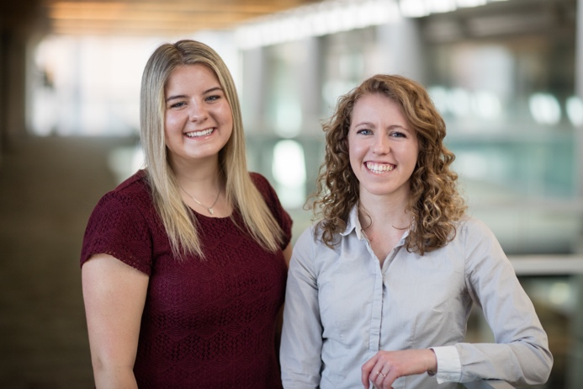
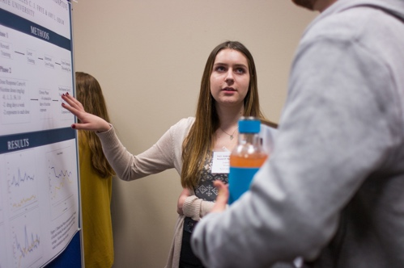
Sociology fellows Rachael Gulbrandsen and Mary Briggs Ott have been analyzing gender and its impact on career aspirations for USU Honors students over time. They will present their poster at the National Conference of Undergraduate Research.

Presentations at USU and Beyond

Fall Student Research Symposium
The FSRS is a great opportunity for fellows that are graduating in December—it’s one of the only fall presenting opportunities, and includes both oral and poster presentations across disciplines. Applications are due in October each year for the December event!
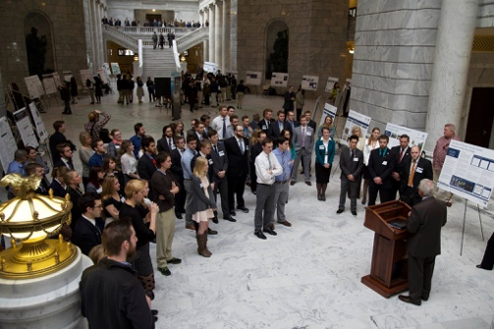
Research on Capitol Hill
This unique event is held early each spring and gives students from USU and the University of Utah an opportunity to speak directly to Utah lawmakers about their research and the impact that doing research has on undergraduate education. The event is on February 28, and it’s open to the public. Come support your fellows!

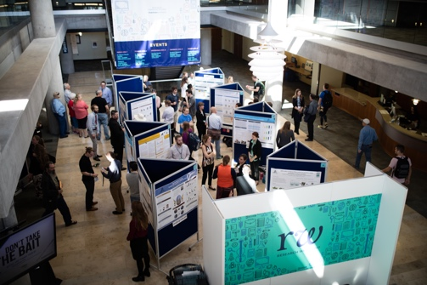
Student Research Symposium
Applications are due on February 15 for this event in April. All who apply are accepted to talk about their work, in poster or oral presentations. This is a great way to test out material you intend to present at other events, or to overcome any anxiety about public speaking!

We have a lot of exciting presentation opportunities each year at USU. As URFs, you have the advantage of finding out about these deadlines and getting involved early enough in your undergraduate careers to take advantage of as many events as you want to. Many of you have done just that!
Fall Student Research Symposium
This year, fellows Cassandra Bovee (Biology), Ben Lovelady (Physics), and Isabella Stuart (Biology) presented their research to an audience of about 100 people.
Utah Conference of Undergraduate Research
UCUR is hosted by a different Utah institute each year. In February, USU will take a team of researchers down to Southern Utah University to present to over 500 people. This team includes fellows Catherine Miner (Political Science), Paul Consalvo (Civil Engineering), Bethany Jensen (Biological Engineering), Frost Mitchell (Computer Engineering), Morgan Sanford (English), Matthew Thompson (Biology), and Kyleigh Tyler (Animal, Dairy & Veterinary Sciences).
Research on Capitol Hill
Last year’s event was cancelled due to weather, but this year we have another strong roster including fellows Anders Hart (Conservation & Restoration Ecology), Morgan Sanford (English), Isabella Stuart (Biology), Jackie Sullivan (Economics), Matthew Thompson (Biology), Paden Thompson (Computer Engineering), and AJ Walters (Biological Engineering).

National Conference of Undergraduate Research
NCUR is hosted by a different institution throughout the US each year; this year, we’ll send representatives from USU to the University of Central Oklahoma in April to showcase our best researchers. Fellows Catherine Miner (Political Science), Morgan Sanford (English), Anders Hart (Conservation & Restoration Ecology), Matthew Thompson (Biology), Rachael Gulbrandsen (Sociology), and Mary Briggs Ott (Sociology) have been accepted to represent us there.
Student Research Symposium
Many of our fellows will recall presenting at this event last spring, and can tell you how great an opportunity it is! Be sure to apply by February 15 to participate on April 12 as part of our Research Week here at USU.
Ignite USU
This event is also part of Research Week and will include TEDx-style talks from a handful of specially-chosen student researchers. We’re proud to say that this year’s roster includes fellows Bethany Jensen (Biological Engineering) and Paul Consalvo (Civil Engineering)!
Bethany will talk about her research on using technology to combat algal blooms, and Paul will be covering water use in toilets in multi-unit residential buildings.
Senior Hyrum Tennant, in Environmental Engineering, reminds you: “Get involved in research early. Start pestering professors about working for them from day one. Research experience is the most valuable thing you can have upon graduating besides your degree.”

All year, every year, we have a handful of fellows working away on URCO grants – Undergraduate Research and Creative Opportunity funding for students in all disciplines.

URCO Grants & Other Achievements
We have six students currently researching independent projects through the URCO program.
*Isabella Stuart, Psychology, is working on her Fall 2017 project ‘The Effects of Nicotine on Maladaptive Alcohol Drinking’ with Dr. Amy Odum. An anonymous faculty reviewer said of her, ‘This one has start potential!’ Isabella will present on her work at the Research on Capitol Hill event later this month.
*Kenen Goodwin, Watershed Sciences, is crossing discipline borders to work with a Biology mentor on his Spring 2018 project ‘Characterizing temporal variation in the skin-associated microbiome of the salamander Ambystoma mavortium’ with Dr. Zachariah Gompert. Said one reviewer of his proposal, ‘FUND IT.’
*Jacklyn Sullivan, Economics, is working on her Spring 2018 project ‘Affirmative Action Bans: Assessing Impacts in a Cross-State Context’ with Dr. Briggs Depew. Her reviewers recommended her proposal for funding because of its strong potential to contribute to the literature in her discipline.
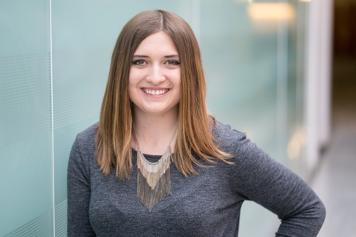

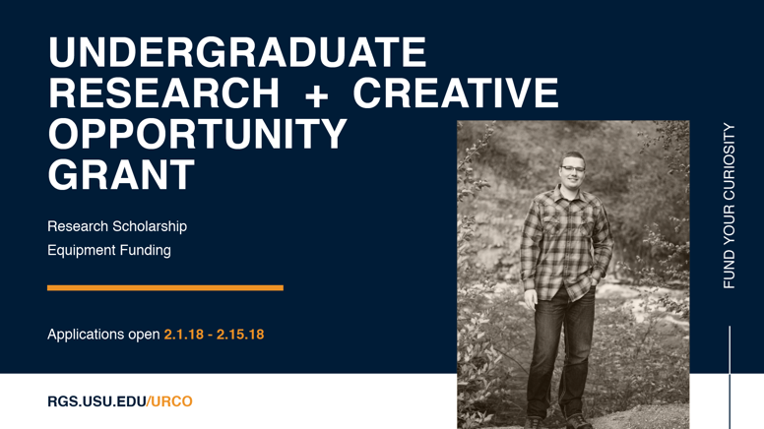
There are a lot of other things going on in your lives. Here are some highlights that prove you’re more than just researchers!
*Benjamin Lovelady, in Physics, applied his research in an unusual cross-collaboration with the History Department to create a 35-foot tall trebuchet that launches up to 1,000 pounds of counterweight.
*Fiona Van Leeuwen, in Chemistry, published an essay in Voices of USU called Borgs and Breasts: The Evolution of the Women of Star Trek.
*Anders Hart, in Conservation & Restoration Ecology, saw his letter to the editor on environmental protections published in the Herald Journal.
*Likewise, Alyssa Burton in Music therapy and her research group published a piece in the Herald Journal on local school boards.
*AJ Walters received Honorable Mention for the Barry Goldwater Scholarship, an incredible achievement recognizing his research in Biological Engineering.
*Tucker Gamble, a Human Movement Science major, got married on December 15 (and was excited about it).
*Matthew Hansen in Electrical Engineering is engaged to be married on June 9, 2018.
* Rachel Sagers in Biology conducted research this fall on how USU Facilities can help birds see windows more easily. Her work will directly make a difference here on campus in preventing bird deaths!

URCO Grants
Students are able to apply for as many URCO grants as they choose, and can be awarded twice. This is a great opportunity to gain experience in grant-writing, receive training and funding, and carry out an independent project from conception to presentation.

Apply by february 15 for Summer 2018
https://urco.usu.edu/

Our fellows never rest. Students worked tirelessly through the summer term, from working to save money for the upcoming year to carrying out research and fieldwork to serving in humanitarian projects throughout the world. Here are a few highlights from your reports!
*Erin Butikofer, a sophomore in Wildland Ecology & Management, spent her summer running a survey throughout the state on perceptions of wildlife damange on agriculture.
*Michaela Brubaker, a junior in Animal, Dairy and Veterinary Sciences, applied her learning to a summer internship at Sanctuary One, an animal sanctuary and care farm in Oregon. While she didn’t research, she built strong connections with veterinarians and gained a lot of experience.
*Dana Sorensen, a senior in Computer Engineering, spent last summer as an intern at the Rincon Research Corporation.
*Bethany Jensen, a senior in Biological Engineering, interned at WesTech Engineering, a wastewater engineering firm
*Emma German, a junior in Mechanical Engineering, is spending her spring and summer down in Salt Lake City, interning at the Federal Bureau of Investigation.

*Catherine Miner, a sophomore in Political Science, is currently a legislative intern for Senator Lyle Hillyard through the USU Institute of Government and Politics.
*Colton Lindstrom, a senior in Electronic Engineering, and Dana Sorensen, a senior in Computer Engineering, have summer internships lined up with Sandia National Labs in Albuquerque, New Mexico.
*Esther Davis, a sophomore in Mechanical Engineering, is a USU Permatulture Initiative Assistant, reminding us that your major should not limit your research and academic interests!

Many more of you indicated that you’re in the process of applying for research opportunities, internships, study abroad programs, jobs, or humanitarian work for the coming summer, with locations as varied as Tennessee, Belize and Swaziland! Keep us posted as you find out where you’ll be.
If you don’t have summer plans yet, consider applying for a research opportunity!

Says Colton about his internship this summer: “Research is also a great way to get networked with professors. My mentor has provided internship opportunities for his students at companies such as NASA and JPL. Finding a job will not be hard when you've networked with research professors.”

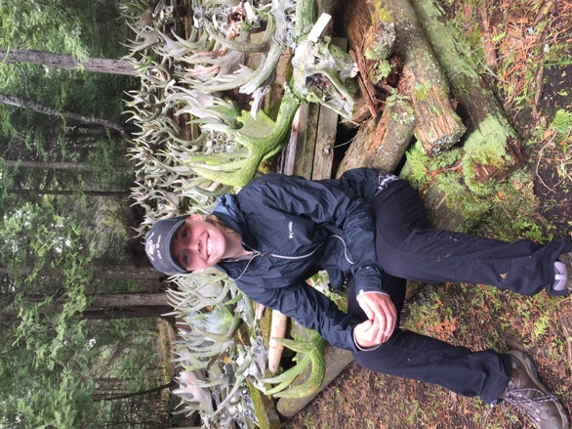

Rylee Jensen, a Wildlife Ecology and Management major, spent a month backpacking around Isle Royale with three other interns taking measurements on balsam fir trees to determine the effect of moose overbrowsing.

Service
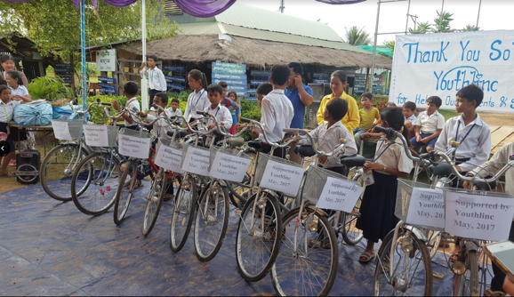

Summer Activities & Internships
Jessica Christensen
Jessica spent time in Cambodia this summer working with an organization focusing on preserving the history and culture of the Khmer people. She strongly recommends sugar cane juice!
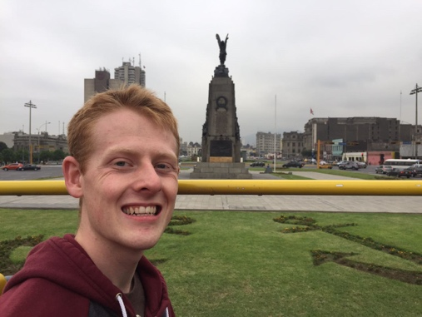
Anders Hart
Anders went down to Peru to work with a community devastated by flooding last spring. They focused on medicinal plant education and on a fundraiser to help the community access healthy food!
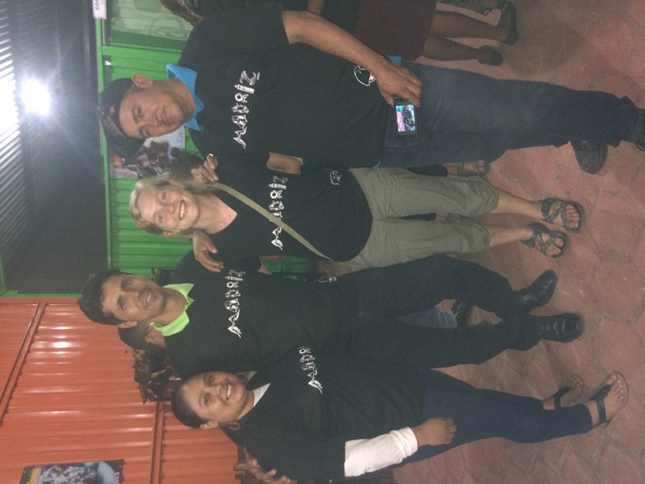
Casey Trout
Casey spent her summer in Madriz, Nicaragua. She was working with four small communities in the region, high-schoolers from the US participating in a cultural exchange program, and employees from the global nonprofit Plan International.

Undergraduate Research Fellows  Semester Updates  Spring 2018  Utah State University |  | Scott Bates, URF Program Director  Office of Research & Graduate Studies  Utah State University  Athena Dupont, URF Program Coordinator  Office of Research & Graduate Studies  Utah State University

